I. Look at the pictures. Write the words.
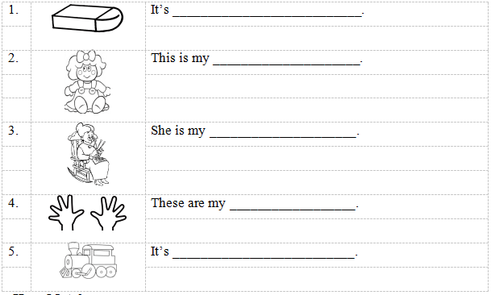
II. Match.
1. | Where’s the ball? | a. | My favorite color is yellow.
2. | How are you today? | b. | Good morning, teacher.
3. | What’s your favorite color? | c. | I’m great. Thank you.
4. | Is she your mom? | d. | It’s on the slide.
5. | Good morning, children. | e. | Yes, she is.
III. Write.
in, on, under
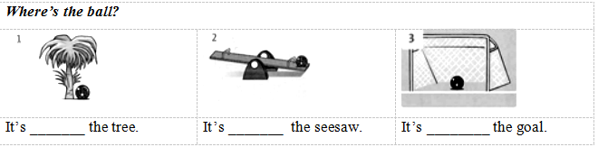
IV. Look at the pictures. Look at the letters. Write the words.
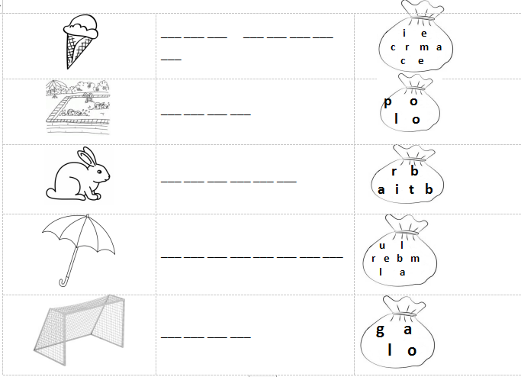

V. Look at the pictures and write.
in; on; under
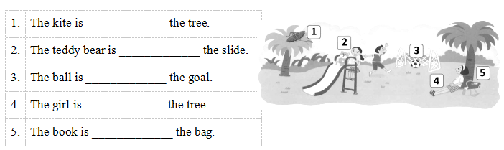
VI. Circle the odd–one–out.
1. | A. ten | B. seven | C. cousin | D. three
2. | A. slide | B. orange | C. black | D. green
3. | A. doctor | B. teacher | C. police officer | D. pencil
4. | A. head | B. book | C. pencil case | D. rubber
5. | A. van | B. car | C. bike | D. yo-yo
VII. Order the words.
1. eyes./ my/ are/ These
_______________________________________________
2. windows/ many/ there?/ are/ How à _______________________________________________
3. firefighter?/ a/ Is/ he
_______________________________________________
4. doctor./ isn’t/ She/ a
_______________________________________________
5. favorite/ yellow./ color/ My/ is
_______________________________________________
VIII. Write.
are; you; old; name; fine;
Nga: Hi!
Tony: Hello!
Nga: What’s your _____1_____?
Tony: My name is TONY.
Nga: How ____2___ you?
Tony: I’m fine. Thank _____3___. And you?
Nga: I’m _____4___. Thanks.
Tony: How ___5____ are you?
Nga: I’m eight years old.
ĐÁP ÁN
Look at the pictures. Write the words.
1 - rubber; 2 - doll; 3 - grandma; 4 - hands; 5 - a train
II. Match
1 - d; 2 - c; 3 - a; 4 - e; 5 - b
III. Write.
1 - under; 2 - on; 3 - in
IV. Look at the pictures. Look at the letters. Write the words
1 - ice cream
2 - pool
3 - rabbit
4 - umbrella
5 - goal
V. Look at the pictures and write.
1- on; 2 - on; 3 - in; 4 - under
VI. Circle the odd–one–out. Write the answers.
1 - C; 2 - A; 3 - D; 4 - A; 5 - D
VII. Order the words.
1 - These are my eyes.
2 - How many windows are there?
3 - Is he a firefighter?
4 - She isn’t a doctor.
5 - My favorite color is yellow.
VIII. Write.
Nga: Hi!
Tony: Hello!
Nga: What’s your _____1. name_____?
Tony: My name is TONY.
Nga: How ____2. are___ you?
Tony: I’m fine. Thank _____3. you___. And you?
Nga: I’m _____4. fine___. Thanks.
Tony: How ___5. old____ are you?
Nga: I’m eight years old.

