I. Look and complete the words
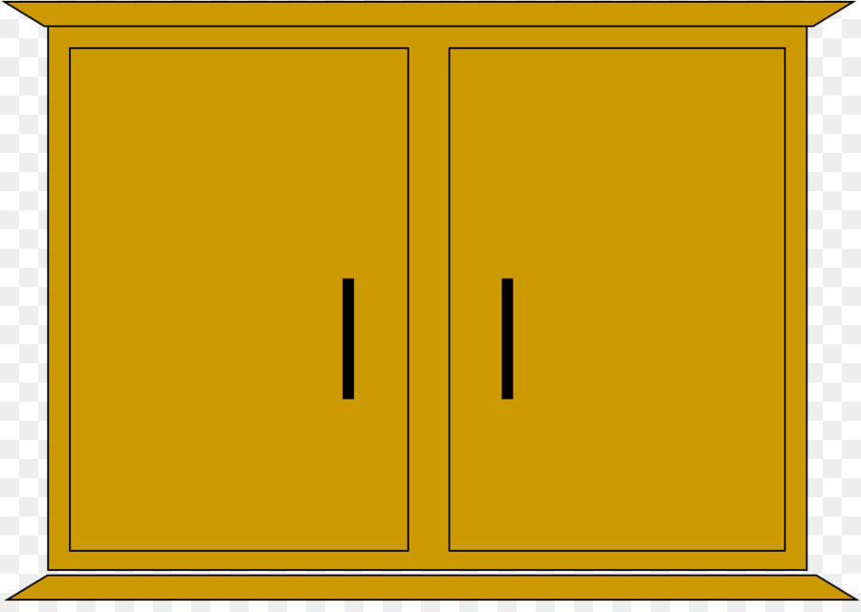 | 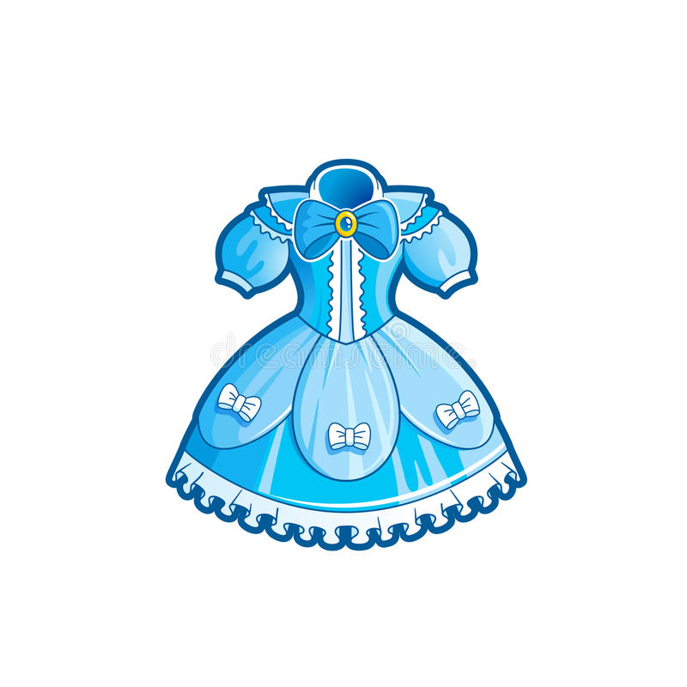 | 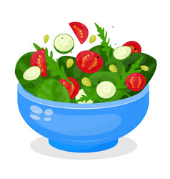
1. c _ b _ _ e t | 2. _ r _ s _ | 3. _ a l _ _
 | 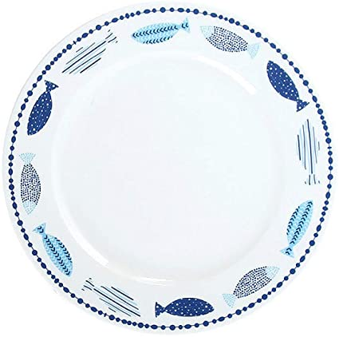 | 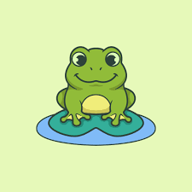
4. _ a _ _ o _ n | 5. p _ a _ e | 6. _ r _ g
Xem đáp án
1. cabinet | 2. dress | 3. salad
4. balloon | 5. plate | 6. frog
II. Choose the odd one out
1. A. grapes | B. orange | C. lemon | D. green
2. A. subject | B. art | C. music | D. English
3. A. rug | B. pillow | C. blanket | D. teacher
4. A. fox | B. hop | C. elephant | D. crow
5. A. fifty | B. twelve | C. shelf | D. thirteen
Xem đáp án
1. D | 2. A | 3. D | 4. B | 5. C
III. Look at the picture and answer the following questions
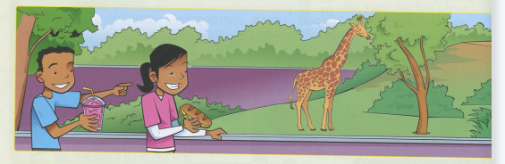
1. How many people are there?
_________________________________
2. Is she wearing a pink dress?
_________________________________
3. Does the giraffe have four legs?
_________________________________
4. Does the boy have a pizza?
_________________________________
5. Does the girl have a sandwich?
_________________________________
Xem đáp án
1. There are two people
2. No, she isn’t
3. Yes, it does
4. No, he doesn’t
5. Yes, she does
IV. Reorder the words to have correct sentences
1. it?/ What/ is/ time/
_________________________________
2. sister/ doesn’t/ balloons/ like/ My/ ./
_________________________________
3. from/ to/ children/ The/ school/ to/ Monday/ go/ Friday/ ./
_________________________________
4. do/ have/ What/ we/ Firday/ on/ ?/
_________________________________
Xem đáp án
1. What time is it?
2. My sister doesn’t like balloons.
3. The children go to school from Monday to Friday.
4. What do we have on Friday?
V. Circle the correct answer
1. She likes/ like candy and balloons
2. My brother have/ has Music, Maths and Vietnamese on Tuesday.
3. There is/ are our bags.
Xem đáp án
1. She likes candy and balloons
2. My brother has Music, Maths and Vietnamese on Tuesday.
3. There are our bags.

