Phòng Giáo dục và Đào tạo ...
Đề thi Học kì 2 - Family and Friends
Năm học 2024 - 2025
Môn: Tiếng Anh lớp 3
Thời gian làm bài: 35 phút
(không kể thời gian phát đề)
(Đề số 1)
I. Listen and write Y (Yes) or N (No).
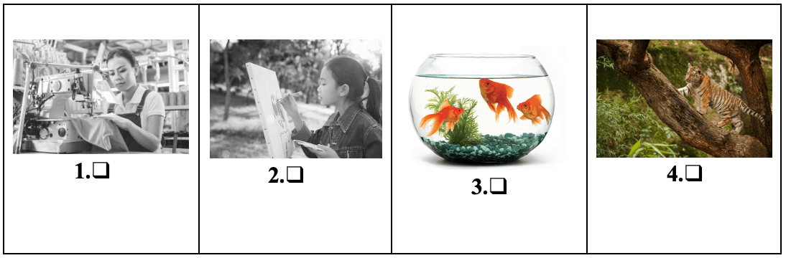
II. Look and write
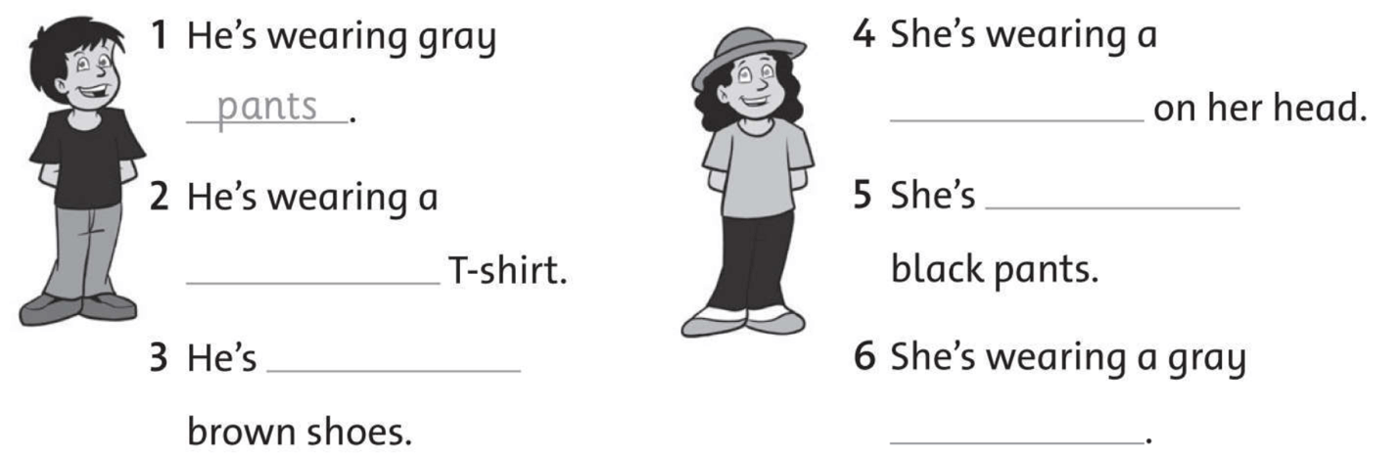
III. Write the words correctly
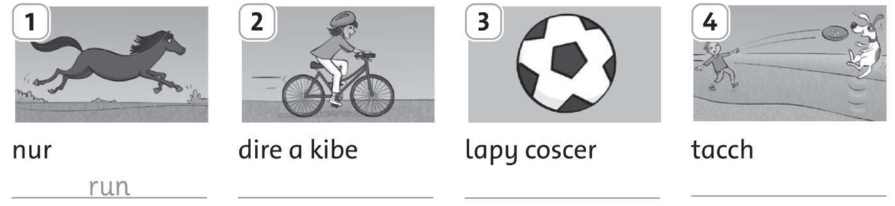
IV. Circle the correct word
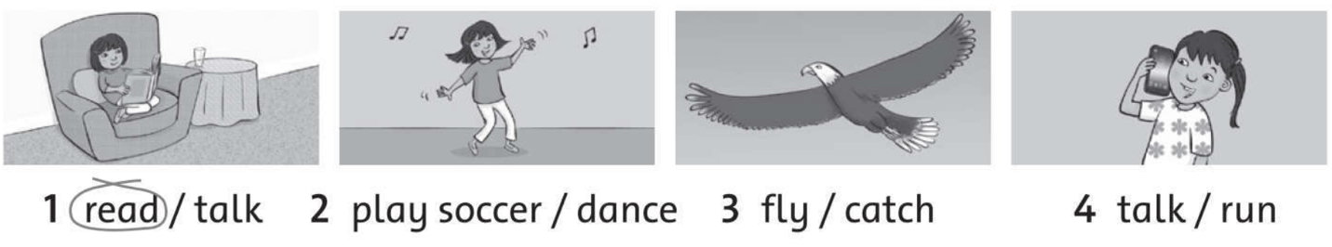
V. Look. Write sentences “can” or “can’t”
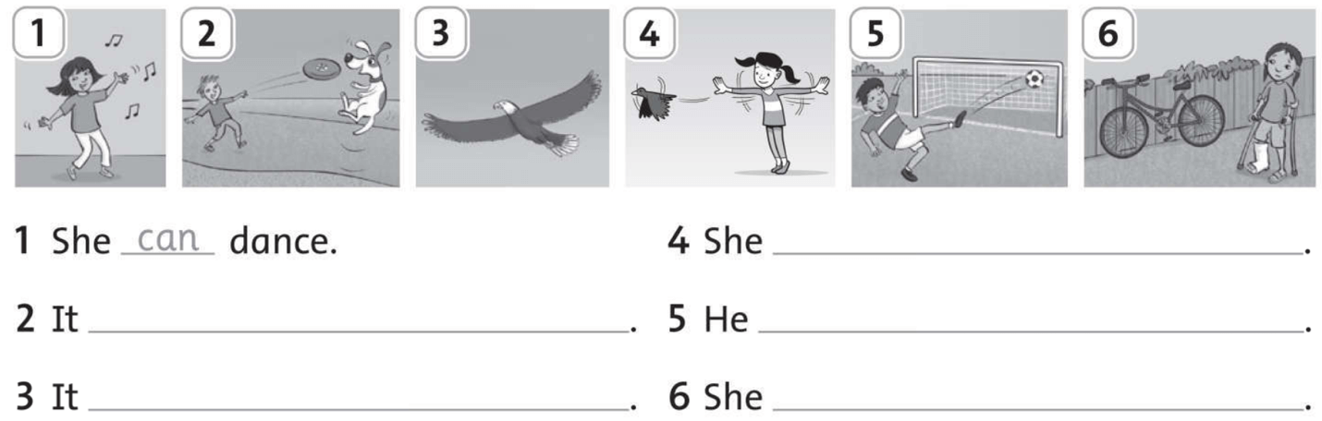
ANSWER KEY
I.
1. N 2. N 3. Y 4. N
Audio script:
1. My sister is a nurse.
2. I’m flying a kite in the park.
3. She has three goldfish.
4. The tiger is dancing.
II.
2. black
3. wearing
4. hat
5. wearing
6. T-shirt
III.
1. run
2. ride a bike
3. play soccer
4. catch
IV.
1. read
2. dance
3. fly
4. talk
V.
2. It can catch.
3. It can fly.
4. She can’t fly.
5. He can play soccer.
6. She can’t ride a bike.

