Phòng Giáo dục và Đào tạo ...
Đề thi Học kì 1 - Global Success
Năm học 2024 - 2025
Môn: Tiếng Anh lớp 3
Thời gian làm bài: 35 phút
(không kể thời gian phát đề)
1. Listen and circle.
1. a. Thank you, Peter.
b. This is my house.
2. a. Hi. Nice to meet you.
b. This is my blue bedroom.
3. a. I like playing chess with my friends
b. Welcome to our classroom!
4. a. Can I have my book back, Mai?
b. My school is near here.
2. Listen and tick.
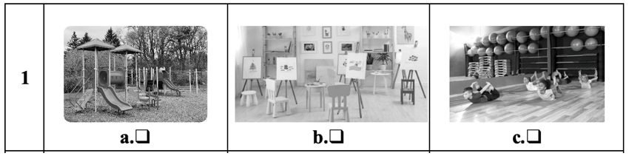
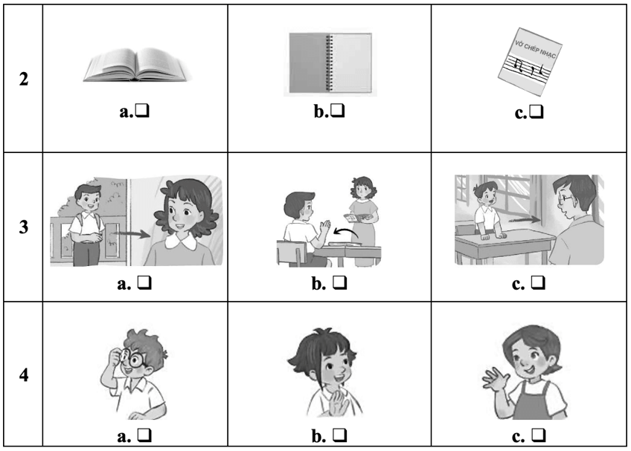
3. Read and tick.
1. A: Hi. I’m Ben
B: Hi, Ben. I’m Mai.
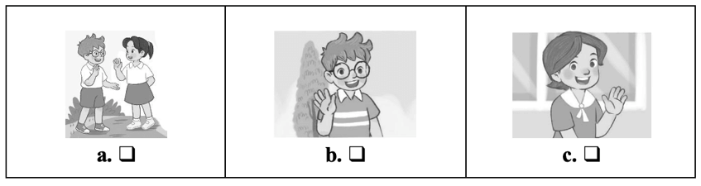
2. A: What’s this?
B: It’s a nose.
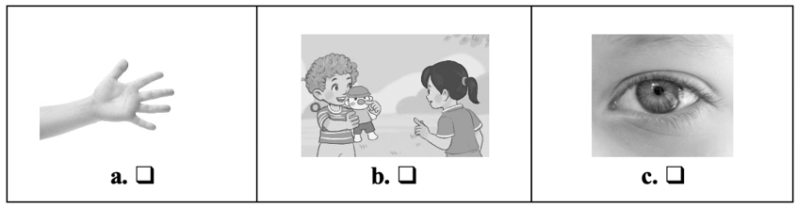
3. I have a pencil case.
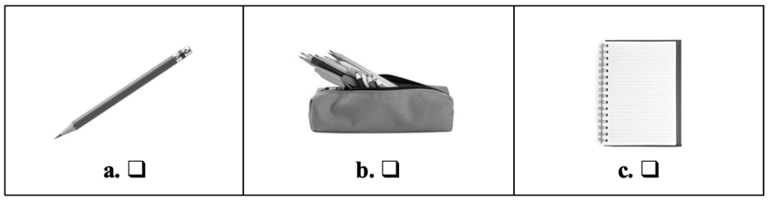
4. It’s break time. Let’s play volleyball.
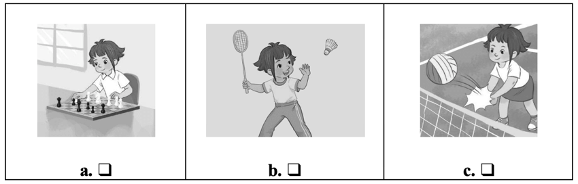
4. Look and write.
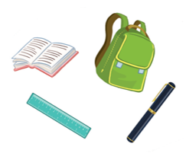
Let’s see what I have. I have a school (1) ______. I (2) ______ a book. I have a (3) _______ and a pen. Oh, I (4) _________ have an eraser.
5. Let’s talk.
1. Greeting/  Responding to greetings | 2. Asking the student’s name/ age | 3. Introducing someone | 4. Asking questions about parts of the body | 5. Asking about hobbies
6. Making suggestions/ Expressing agreement | 7. Giving instructions/ Asking for permission | 8. Asking about school things | 9. Asking about the colours of school things | 10. Talking about break time activities
ANSWER KEY
1.
Key: 1. th 2. h 3. cl 4. oo
Audio script:
1. Thank you, Peter.
2. This is my blue bedroom.
3. Welcome to our classroom!
4. My school is near here.
Key: 1. a 2. b 3. b 4. b
2.
Audio script:
1. A: Let’s go to the playground.
B: OK, let’s go.
2. A: Bill, be quick. Let’s go to the music room.
B: OK. My music notebook is here.
3. Woman: Come in and sit down, Nam.
4. Mum, this is my friend, Linh.
Key: 1. a 2. c 3. a 4. b
3.
1. a 2. b 3. b 4. c
4.
(1) bag (2) have (3) ruler (4) don’t
5.
Suggested questions and answers:
1. Hello, (pupil’s name). How are you? (Giving clues: Are you fine?/ OK? Yes? No?)
2. Hi! My name’s _____________. What’s your name?/ How old are you?
(Giving clues: My name’s ____./ I’m _____ and you are _______./
Are you ______? Yes? No?)
3. Is this (one pupil’s name)?
4. What’s this?/ Touch your (a body part).
(Point to any body parts learnt to ask or give commands to check pupil’s understanding.)
5. What’s your hobby? (Giving clues: Do you like (swimming)? Swimming? Yes? No?)
6. Is this __________?
Let’s ___________.
7. May ___________?
(Point to one flash card, have the pupil give instructions or ask for permission.)
8. I have _______. Do you have _______?
9. What colour is it? What colour are they? (Giving clues: Is it red? Yes? No?)
10. I play badminton at break time. What about you, (pupil’s name)?
For some topics, the teacher points to the flash card or realia, has the pupils listen and say/ respond. Depending on the pupil’s speaking performance, the teacher can give him/ her some clues to encourage him/ her to speak English.

