I. Đề thi Tiếng Anh lớp 3 học kì 1 Global Success
Choose the odd one out
1. A. school bag | B. gym | C. rubber | D. notebook
2. A. color | B. black | C. pink | D. yellow
3. A. playground | B. music room | C. library | D. mouth
4. A. ear | B. eye | C. touch | D. face
5. A. hobby | B. dancing | C. singing | D. swimming
Look at the pictures and complete the words
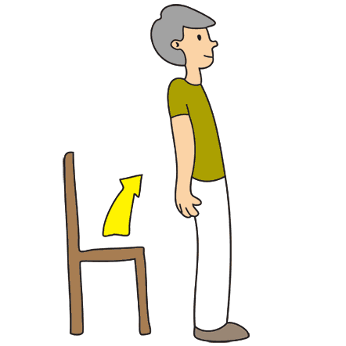 |  | 
1. s _ a n d _ _ | 2. _ o m _ _ t _ r r _ _ m | 3. r _ l _ r
Choose the correc answer A, B, C or D
1. Our school’s …………. room is old.
A. ground
B. school
C. music
D. the
2. I play and chat ……….. my friends after school.
A. with
B. to
C. at
D. on
3. What ……………. he do in the morning?
A. do
B. does
C. are
D. is
4. That ………… a window. It’s a door.
A. is
B. are
C. isn’t
D. aren’t
5. My ………….. color is pink.
A. hobby
B. like
C. love
D. favourite
Read and decide if each statement is true (T) or false (F)
My name is Jen. I’m seven years old and this is my school bag. There are many things in the school bag. This is my ruler. It’s new and long. These are my books and my notebooks. They are nice and new. Look! This is my pencil. It’s old and short. And those are my pens. They are short, too.
1. Jen is 8 years old.
2. There are many things in Jen’s school bag.
3. Jen’s ruler is old.
4. Jen’s books are nice.
5. Jen’s notebooks are new.
Read and match
1. Is this our playground? | A. It’s black and white.
2. Let’s go to the library | B. No, you can’t
3. Can I go out? | C. Yes, I do
4. Do you have a notebook? | D. OK, let’s go
5. What color is it? | E. Yes, it is
Find the mistakes in each sentence and correct it
1. Open you book, please!
_____________________________________
2. Which book does you read regularly?
_____________________________________
3. “May me come in?” - “Please, do”
_____________________________________
4. Please sit down for an while
_____________________________________
5. “May I going out?” - “Yes, you can”
_____________________________________
Reorder the words to make correct sentences
1. are/ my/ not/ These/ notebooks/ ./
_____________________________________
2. up/ I/ early/ get/ ./
_____________________________________
3. is/ your/ colour/ pencil/ What/ case/ ?/
_____________________________________
4. she/ Does/ play/ to/ hide-and-seek/ like/ ?/
_____________________________________
5. very/ are/ My/ colorful./ pictures/
_____________________________________

II. Đáp án đề thi Tiếng Anh lớp 3 học kì 1 Global Success
Choose the odd one out
1. B | 2. A | 3. D | 4. C | 5. A
Look at the pictures and complete the words
1. stand up | 2. computer room | 3. ruler
Choose the correct answer A, B, C or D
1. C | 2. A | 3. B | 4. C | 5. D
Read and decide if each statement is true (T) or false (F)
1. T | 2. T | 3. F | 4. T | 5. T
Read and match
1. E | 2. D | 3. B | 4. C | 5. A
Find the mistakes in each sentence and correct it
1. you => your
Open your book, please!
2. does => do
Which book do you read regularly?
3. me => I
“May I come in?” - “Please, do”
4. an => a
Please sit down for a while
5. going => go
“May I go out?” - “Yes, you can”
Reorder the words to make correct sentences
1. These are not my notebooks.
2. I get up early.
3. What colour is your pencil case?
4. Does she like to play hide-and-seek?
5. My pictures are very colorful.

