Ex 1. Listen and circle.
1. a. Thank you, Peter.
b. This is my house.
2. a. Hi. Nice to meet you.
b. This is my blue bedroom.
3. a. I like playing chess with my friends
b. Welcome to our classroom!
4. a. Can I have my book back, Mai?
b. My school is near here.
Ex 2. Listen and tick.
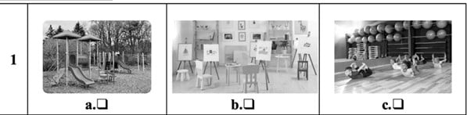
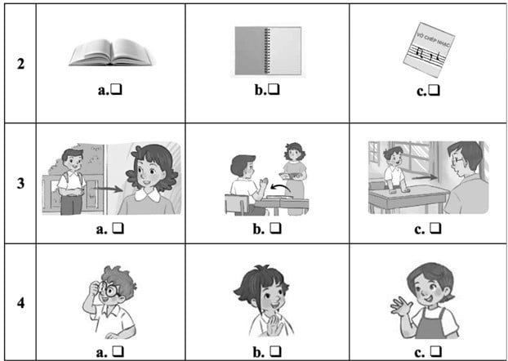
Ex 4. Look and write.
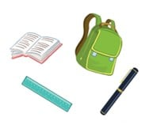

Let’s see what I have. I have a school (1) ______. I (2) ______ a book. I have a (3) _______ and a pen. Oh, I (4) _________ have an eraser.
Ex 5. Let’s talk.
1. Greeting/ Responding to greetings
2. Asking the student’s name/ age
3. Introducing someone
4. Asking questions about parts of the body
5. Asking about hobbies
6. Making suggestions/ Expressing agreement
7. Giving instructions/ Asking for permission
8. Asking about school things
9. Asking about the colours of school things
10. Talking about break time activities
Ex 6, Choose the correct answer A, B, C or D
1. Hello, how are you? - I am …………
A. fine
B. five
C. six
D. eight
2. My name is Sara. What about …………?
A. my
B. he
C. you
D. me
3. What ………… this?
A. is
B. are
C. am
D. be
4. How old is _______?
A. your teachers
B. his teachers
C. her teachers
D. their teacher
5. I like …………..
A. run
B. running
C. runing
D. runs
Ex 7, Read the text and answer the questions
My name is Linda. I am eight years old. I am from Vietnam. I have got a friend. He is from Japan. I am a pupil and my friend is a pupil, too. He likes dancing and drawing. I like cooking. I usually cook with my mom at the weekends.
1. How old is the girl?
___________________________________
2. Where is she from?
___________________________________
3. Where is her friend from?
___________________________________
4. What is her hobby?
___________________________________
5. What is his hobby?
___________________________________
Ex 8, Reorder these words to have correct sentences
1. is/ nine/ She/ old/ years/ ./
___________________________________
2. hobby/ is/ His/ walking/ ./
___________________________________
3. is/ teacher/ my/ This/ ./
___________________________________
ĐÁP ÁN
Ex 1.
Key: 1. th 2. h 3. cl 4. oo
Audio script:
1. Thank you, Peter.
2. This is my blue bedroom.
3. Welcome to our classroom!
4. My school is near here.
Key: 1. a 2. b 3. b 4. b
Ex 2.
Audio script:
1. A: Let’s go to the playground.
B: OK, let’s go.
2. A: Bill, be quick. Let’s go to the music room.
B: OK. My music notebook is here.
3. Woman: Come in and sit down, Nam.
4. Mum, this is my friend, Linh.
Key: 1. a 2. c 3. a 4. b
Ex 3.
1. a 2. b 3. b 4. c
Ex 4.
(1) bag (2) have (3) ruler (4) don’t
Ex 5.
Suggested questions and answers:
1. Hello, (pupil’s name). How are you? (Giving clues: Are you fine?/ OK? Yes? No?)
2. Hi! My name’s _____________. What’s your name?/ How old are you?
(Giving clues: My name’s ____./ I’m _____ and you are _______./
Are you ______? Yes? No?)
3. Is this (one pupil’s name)?
4. What’s this?/ Touch your (a body part).
(Point to any body parts learnt to ask or give commands to check pupil’s understanding.)
5. What’s your hobby? (Giving clues: Do you like (swimming)? Swimming? Yes? No?)
6. Is this __________?
Let’s ___________.
7. May ___________?
(Point to one flash card, have the pupil give instructions or ask for permission.)
8. I have _______. Do you have _______?
9. What colour is it? What colour are they? (Giving clues: Is it red? Yes? No?)
10. I play badminton at break time. What about you, (pupil’s name)?
For some topics, the teacher points to the flash card or realia, has the pupils listen and say/ respond. Depending on the pupil’s speaking performance, the teacher can give him/ her some clues to encourage him/ her to speak English.
Ex 6: Choose the correct answer A, B, C or D
1. A 2. C 3. A 4. D 5. B
Ex 7: Read the text and answer the questions
1. She is eight years old.
2. She is from Vietnam.
3. He is from Japan.
4. She likes cooking.
5. He likes dancing and drawing.
Ex 8: Reorder these words to have correct sentences
1. She is nine years old.
2. His hobby is walking.
3. This is my teacher.

Đề số 02
Ex 1: Choose the best answer
1. The coat is ………………. on the desk. It’s on the chair.
A. not
B. aren’t
C. isn’t
2. ….……….. you like some milk? - No, thanks.
A. What
B. Where
C. Would
3. Would you like some …………?
No, thanks. I’d like some drink.
A. drink
B. food
C. thing
4. A: Is there a fence around your house?
B: No, there …………..
A. is
B. aren’t
C. isn’t
5. How ………….. books are there on the table?
There are three books
A. much
B. very
C. many
Ex 2: Under and corrrect the mistakes
1. He doesn’t have a balloon. He have a car.
….…………………………………………………………….
2. Does they have books?
….…………………………………………………………….
Ex 3: Read the text and answer the questions
I am Robert. This is a photo of my family. This is my father. He is forty-two years old. He likes reading news. This is my mother. She is thirty-five years old. She is a housewife. She likes cooking. This is my brother. His name is Jack. Jack is only two years old. This is my sister. Her name is Ann. She is eight years old. I am eleven years old. I love my family.
1. How old is Robet’s father?
….…………………………………………………………….
2. What does his mother like doing?
….…………………………………………………………….
3. What is his mother’s job?
….…………………………………………………………….
4. How old is Jack?
….…………………………………………………………….
5. How old is Robert?
….…………………………………………………………….
Ex 4: Reorder the words to make meaningful sentences
1. old/ his/ How/ is/ sister/?/
….…………………………………………………………….
2. years/ father/ Her/is/old/ forty -three /./
….…………………………………………………………….
3. brother/ a/ Is/ worker/ your/? /
….…………………………………………………………….
4. dining room/ is/ Where /your/?/
….…………………………………………………………….
5. brown/ like/ house/ don’t / I/a/./
….…………………………………………………………….
Ex 5. Let’s talk.
1. Asking and answering questions about the age of a family member
2. Asking and answering questions about the location of a room in a house
3. Describing things in a room
4. Offering and accepting or declining food or drinks
5. Asking and answering questions about pets
6. Talking about someone’s toys
7. Talking about what someone is doing
8. Talking about what someone is doing outdoors
9. Asking and answering questions about what a zoo animal is doing
10. Asking and answering questions about the job of a family member
Note:
Teacher may use the flash cards of Units 11 - 20 and real things, pictures, … for this Speaking test.
Ex 6, Let’s talk.
1. Asking and answering questions about the job of a family member
2. Asking and answering questions about the location of a room in a house
3. Talking about quantities of things in a room
4. Offering and accepting or declining food or drinks
5. Offering and accepting ordeclining food or drinks
6. Asking and answeringquestions about whatsomeone would like to eator drink
7. Talking about someone’s toys
8. Talking about what someone is doing outdoors
9. Asking and answeringquestions about what animals someone can see at the zoo
10. Asking and answering questions about what a zoo animal is doing
ĐÁP ÁN:
Ex 1: Choose the best answer
1. A 2. C 3. B 4. C 5. C
Ex 2: Under and corrrect the mistakes
1. have => has
He doesn’t have a balloon. He has a car
2. Does => Do
Do they have books?
Ex 3: Read the text and answer the questions
1. He is forty-two years old.
2. She likes cooking.
3. She is a housewife.
4. Jack is only two years old.
5. He is eleven years old.
Ex 4 Reorder the words to make meaningful sentences
1. How old is his sister?
2. Her father is forty-three years old.
3. Is your brother a worker?
4. Where is your dining room?
5. I don’t like a brown house.
Ex 5: Suggested language:
1. - How old is he / she / your father / mother /?
- He’s / She’s ______ (age).
2. - Where’s the ____________ (rooms in a house)?
- It’s here / there.
3. The ________ is _________ (big, new, old, …)
The ________ are ________ (big, new, old, …)
4. - Would you like some ___________ (food / drink)?
- Yes, please. / No, thanks.
5. - Do you have any __________ (pets)?
- Yes, I do. / No, I don’t.
6. They have __________ (toys).
7. I’m _________________ (dancing, drawing a picture, …)
8. He’s / She’s ____________ (cycling, flying a kite, …)
9. What’s the __________ doing? It’s _____________ (climbing, swinging, …)
10. - Is your father / mother / _______ (teacher, nurse, …)?
- Yes, he / she is. / No, he / she isn’t.
Ex 6: Suggested language:
1.- What’s his / her job?
- He’s / She’s ___________ (jobs).
2. - Where’s the _____________ (rooms in a house)?
- It’s here / there.
3. There’s / There are __________ in the room.
4. - Would you like some _________ (food / drink)?
- Yes, please. / No, thanks.
5. - Would you like some _________ (food / drink)?
- Yes, please. / No, thanks.
6. - What would you like to eat / drink?
- I’d like some ___________ (food / drink), please.
7. They have __________ (toys).
8. He’s / She’s ___________ (cycling, flying a kite, …)
9. - What can you see?
- I can see _________ (zoo animals).
10. - What’s the __________ doing?
- It’s ___________ (climbing, swinging, …)

