ĐỀ 1 | ĐỀ THI GIỮA HỌC KỲ II  NĂM HỌC 2025-2026  MÔN: TIẾNG ANH LỚP 1  SÁCH: KẾT NỐI TRI THỨC
PART I. LISTENING
 |  |  |  | Listen and circle (1 point)
 |  |  |  |  |  |  | l |  |  | n
 |  |  |  |  |  |  | m |  |  | n |  |  |  |  |  |  |  |  | o |  |  | w
 |  |  |  |  |  |  | t |  |  | f |  |  |  |  |  |  |  |  | m |  |  | o
 |  |  |  |  | Listen and tick (1 point)
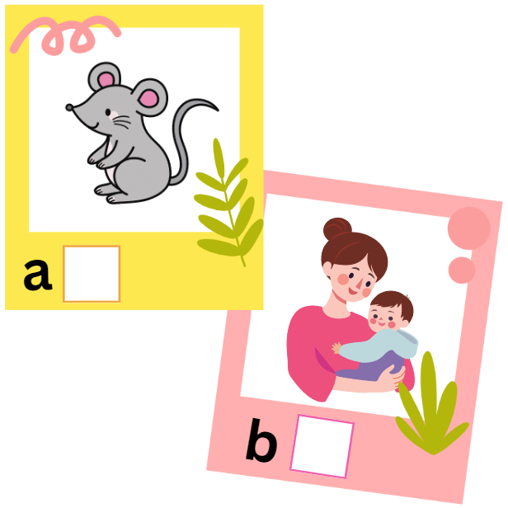

✓

 |  |  |  | 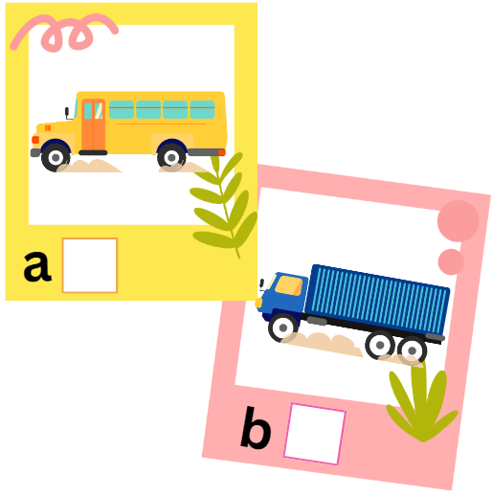 |  |  |  |  |  |  |  |  |  | 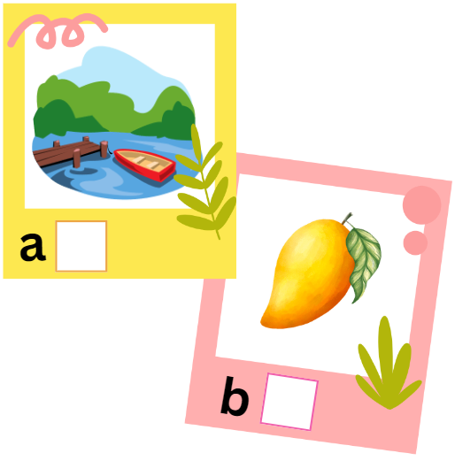
 |  |  |  | 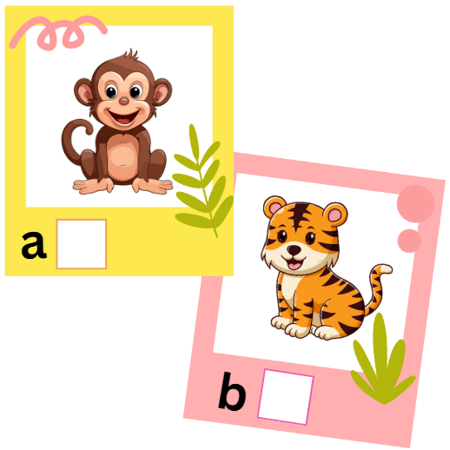 |  |  |  |  |  |  |  |  |  | 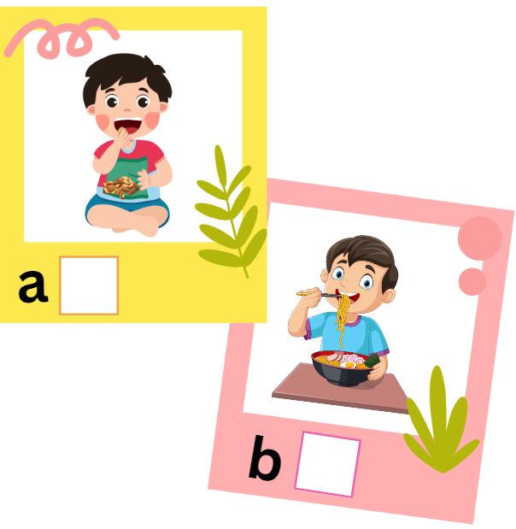
 |  |  |  | Listen and tick (✓) or cross (x) (1 point)
 |  |  | 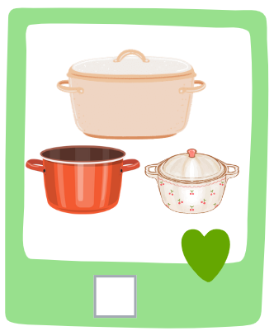  x |  |  |  |  |  |  |  | 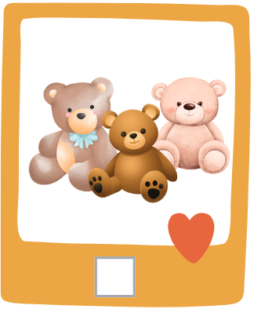 |  |  |  |  |  |  | 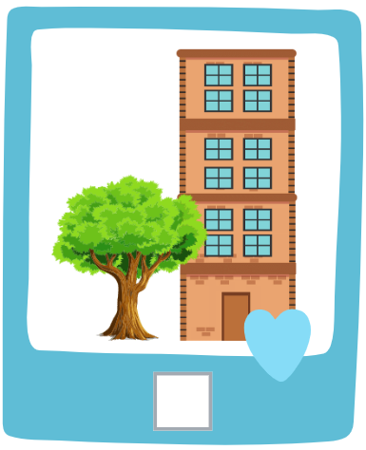
 |  |  |  |  |  |  |  |  |  |  |  |  |  |  |  |  |  | 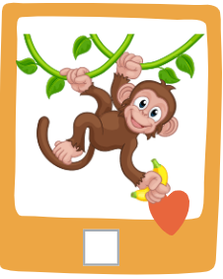

PART II. READING
 |  |  | Read and match (0.75 points)
 |  |  |  |  |  |  |  | 
a mango |  |  |  | a bus | lemons |  |  | mops
 |  |  | Read and choose A, B or C (0.75 points)
 |  | 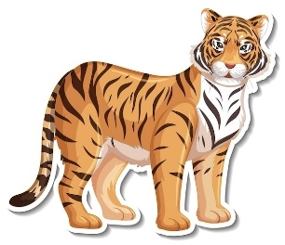 |  |  |  | Look at the ___________.  - leaf  - truck  - tiger
 |  |  |  |  |  | He’s having ___________ today.  - apple  - noodles  - nuts
 |  |  |  |  |  | She’s watching ___________.  - television  - face  - football
 |  |  |  |  |  | - How many windows can you see?  - I can see ___________.  - six  - eight  - ten
PART III. WRITING
 |  |  | Reorder the letters to make a word (2 points)
 |  | 
sun
uns
 |  |  |  |  | 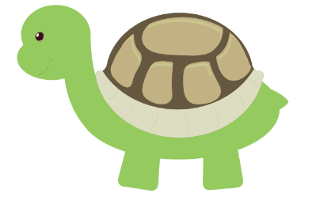
 |  | aecf |  |  | 1.  ettrul
 |  |  |  |  | 
 |  | nbaaan |  |  | kmeyon

 | Reorder the words to make complete sentences (1 point)
- has/ Tony/ top./ a
Tony has a top.
- three/ are/ clocks./ There
_________________________________________________
- is/ mouse./ a/ That
_________________________________________________
PART IV. SPEAKING
 | Introduction (0.5 points)
Teacher asks students to answer questions:
- Hello, what’s your name?
- How are you today?
 | Let’s talk (2 points)
Teacher shows the pictures and asks students to answer questions:
- What are they?
- How many apples/ pots/ teddy bears/ windows can you see?
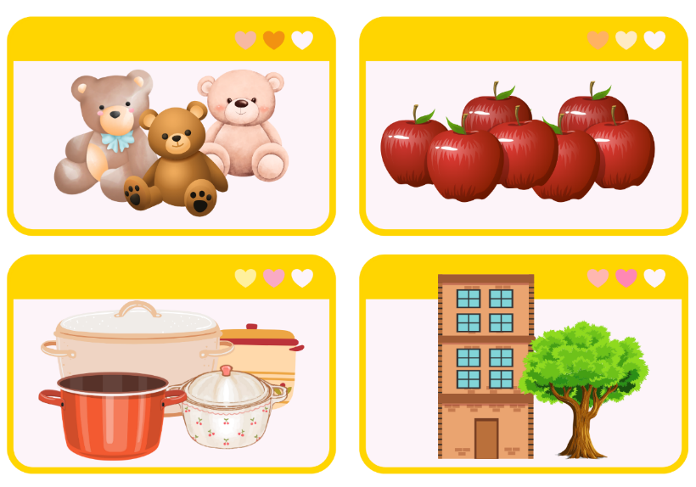
ĐÁP ÁN
PART I. LISTENING
 | Listen and circle (1 point)

 |  | l | n
 |  | m | n |  | o | w
 |  | t | f |  | m | o
 | Listen and tick (1 point)

 |  | ✓
 |  | ✓ |  |  |  | ✓
 |  | ✓ |  |  |  | ✓
 |  | Listen and tick (✓) or cross (x) (1 point)
 | x |  |  | ✓ |  |  |  | x
 |  |  |  | x |  |  |  | ✓
PART II. READING
 |  |  | Read and match (0.75 points)
a mango |  |  |  | a bus | lemons |  |  | mops
 |  |  | Read and choose A, B or C (0.75 points)
 |  | 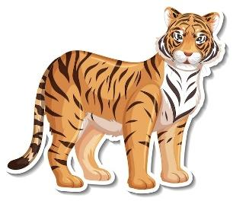 |  |  |  | Look at the ___________.  - leaf  - truck  - tiger
He’s having ___________ today.
- apple

- noodles
- nuts
She’s watching ___________.
- television
- face

- football
- How many windows can you see?
- I can see ___________.
- six

- eight
- ten
PART III. WRITING
 |  |  | Reorder the letters to make a word (2 points)
 |  | 
uns
sun

 |  | aecf  face |  |  | 1.  ettrul  turtle
 |  | nbaaan  banana |  |  | kmeyon  monkey

 | Reorder the words to make complete sentences (1 point)
- has/ Tony/ top./ a
Tony has a top.
- three/ are/ clocks./ There
There are three clocks.
- is/ mouse./ a/ That
That is a mouse.
PART IV. SPEAKING
 | Introduction (0.5 points)
- Hello, what’s your name?
- How are you today?
 | Let’s talk (2 points)
Teacher asks students to answer questions:
How many apples/ pots/ teddy bears/ windows can you see?
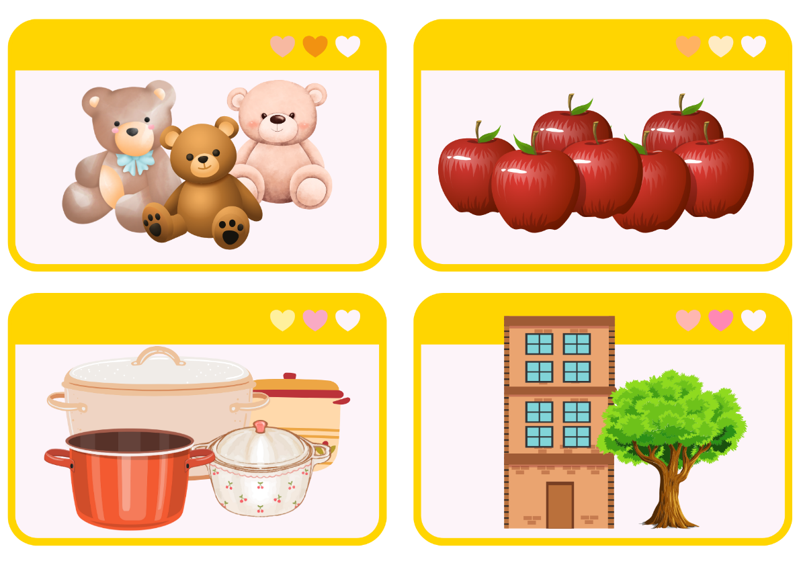
Answers:
I can see three teddy bears.
I can see four pots.
I can see seven apples.
I can see eight windows.

