ĐỀ 2 | ĐỀ THI GIỮA HỌC KỲ II  NĂM HỌC 2025-2026  MÔN: TIẾNG ANH LỚP 1  SÁCH: KẾT NỐI TRI THỨC
PART I. LISTENING
 | Listen and tick (1 point)

✓

 |  | f |  | t
 |  | w |  | n |  |  |  | n |  | l
 |  | u |  | m |  |  |  | m |  | t

 | Listen and choose A, B or C (1 point)

 | 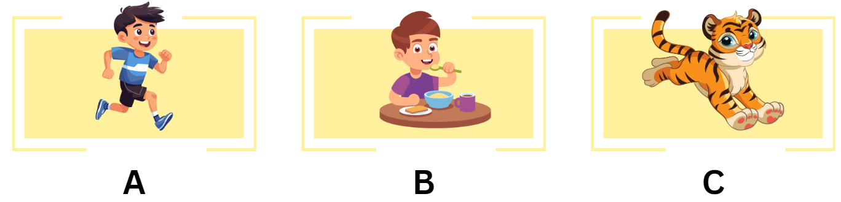
 | 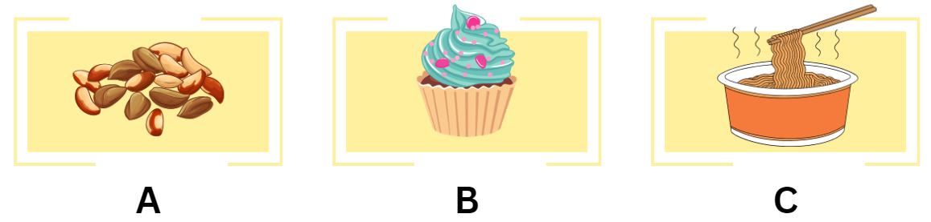
 | 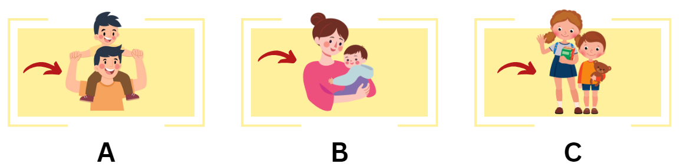
 | 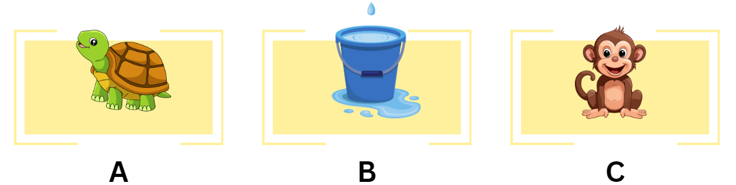
 | 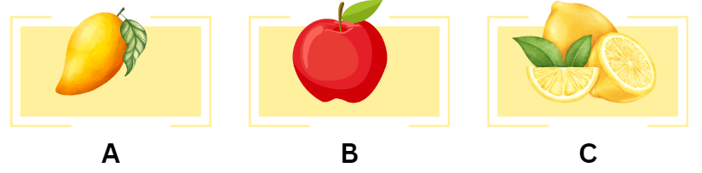
 |  | Listen and tick (✓) or cross (x) (1 point)
 |  |  | ✓ | I can see three clocks.
 |  |  |  | Look at the tiger.
 |  |  |  | She’s having nuts.
 |  |  |  | That’s a bus.
 |  |  |  | Point to your foot!
PART II. READING
 | Read and tick (0.75 points)
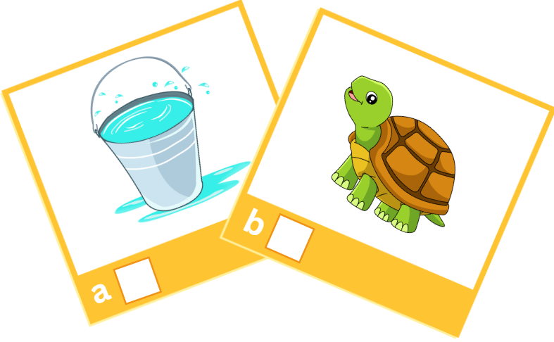  ✓ |  | 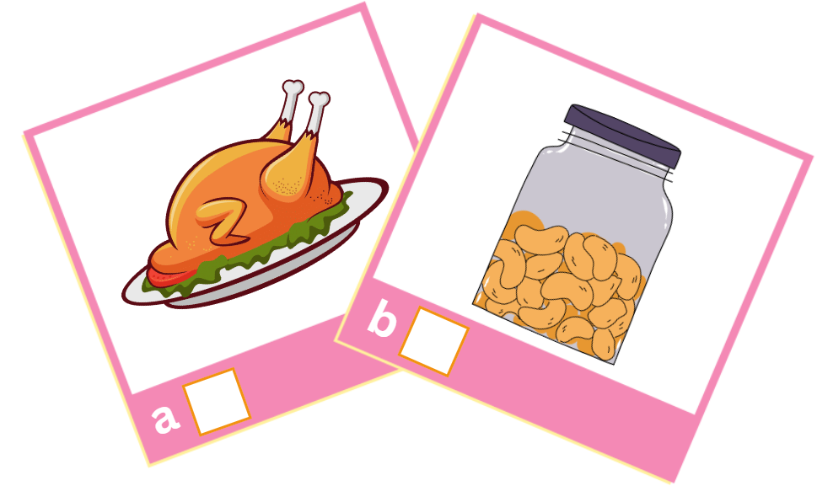
- water |  | - nuts
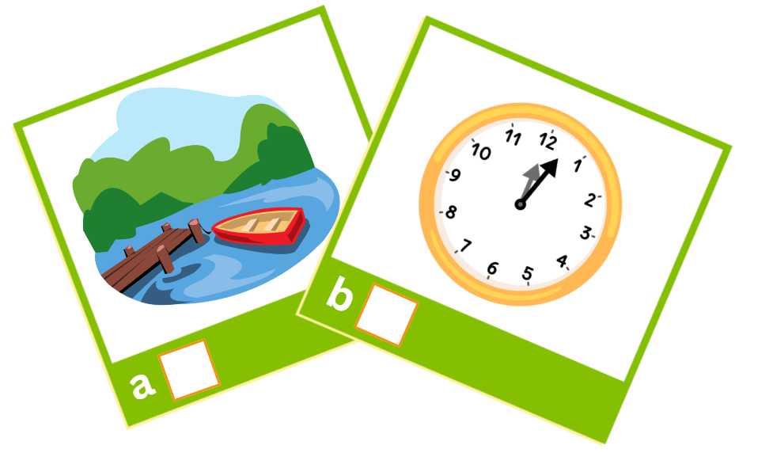 |  | 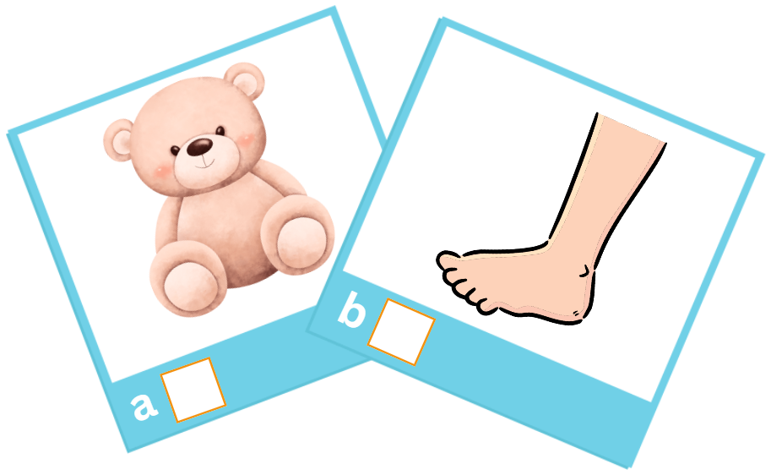
- lake |  | - teddy bear

 |  | Read and tick (✓) or cross (x) (0.75 points)
 |  |  |  | 
  ✓ | That’s a mouse. |  |  | He’s having noodles.
 |  |  |  | 
 | There are five locks. |  |  | Look at the lake.
PART III. WRITING
 | Write the missing letters (1.5 points)

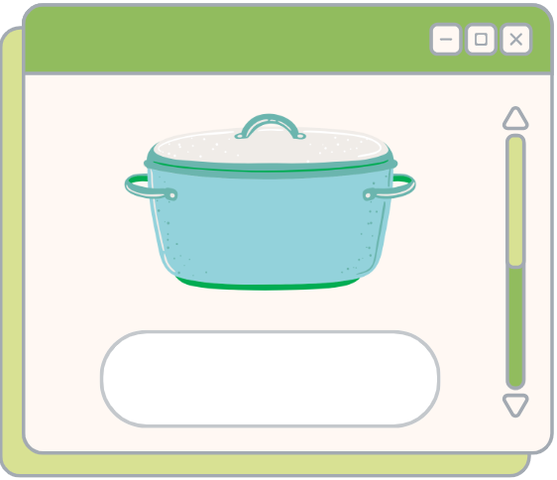
1. t_ _ _ _
0. pot
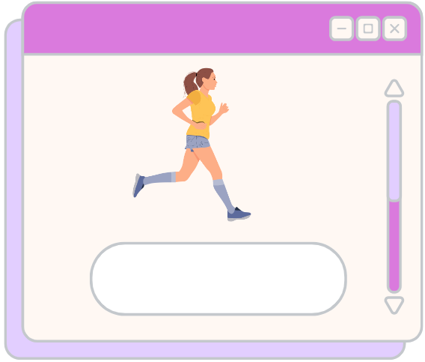
3. _o_
2. _ _ n

 |  | Write the missing words (1.5 points)
 |  |  | 
 | - Look at the lemons. |  | - Point to your ___________.
 |  |  | 
 | - I can see _______________ books. |  | - Tony has a _______________.
PART IV. SPEAKING
 | Introduction (0.5 points)
Teacher asks students to answer questions:
- Hello, what’s your name?
- How are you today?
 |  | Let’s talk (2 points)
 | Teacher shows the pictures and asks students to look at the picture and says the full sentences:

 |  |  | 
That’s _______________. | He’s _______________. | Look at the _______________. | She’s having _____________.
ĐÁP ÁN

PART I. LISTENING
Listen and tick (1 point)
✓

 |  | f |  | t
 | ✓ | w |  | n |  |  |  | n | ✓  ✓ | l
 | ✓ | u |  | m |  |  |  | m |  | t

Listen and choose A, B or C (1 point)

 | 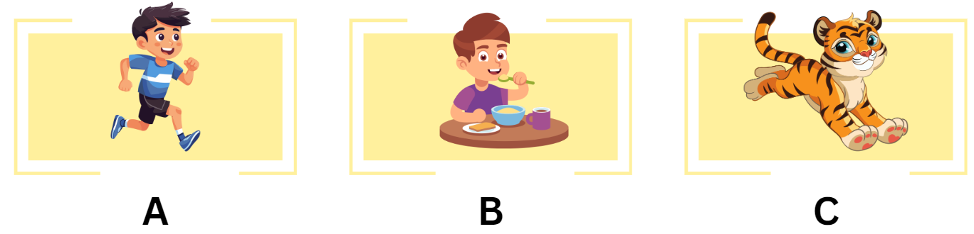
 |  | Listen and tick (✓) or cross (x) (1 point)
 |  |  | ✓ | I can see three clocks.
 |  |  | x | Look at the tiger.
 |  |  | x | She’s having nuts.
 |  |  | ✓ | That’s a bus.
 |  |  | x | Point to your foot!
PART II. READING
 | Read and tick (0.75 points)
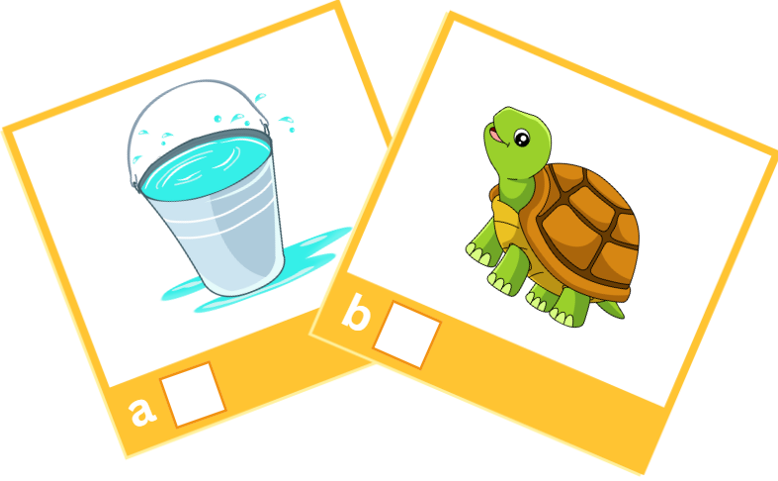  ✓ |  | 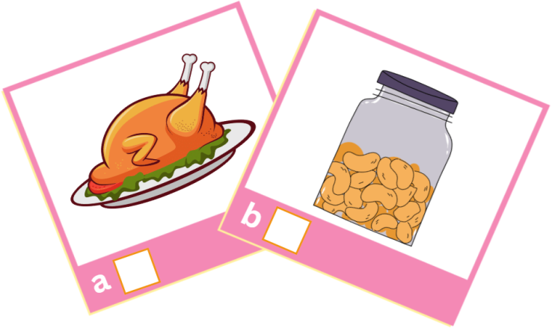  ✓
- water |  | - nuts
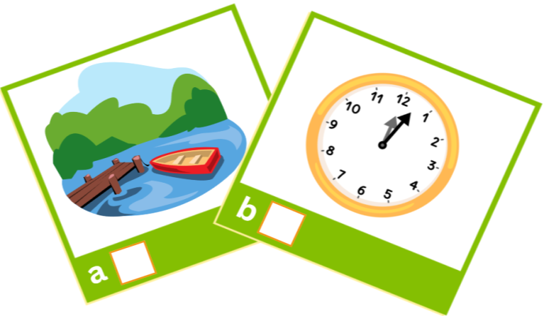  ✓ |  | 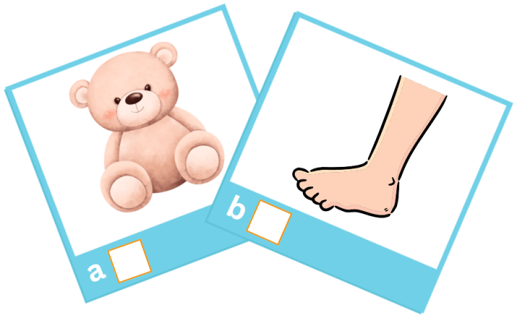  ✓
- lake |  | - teddy bear

 |  | Read and tick (✓) or cross (x) (0.75 points)
 |  |  |  | 
  ✓ | That’s a mouse. |  | x | He’s having noodles.
 |  |  |  | 
✓ | There are five locks. |  | x | Look at the lake.
PART III. WRITING
Write the missing letters (1.5 points)

0. pot
1. truck
2. run
3. top

 |  | Write the missing words (1.5 points)
 |  |  | 
 | - Look at the lemons. |  | - Point to your face.
 |  |  | 
 | - I can see four books. |  | - Tony has a teddy bear.
PART IV. SPEAKING
Introduction (0.5 points)
- Hello, what’s your name?
- How are you today?
Let’s talk (2 points)

 | That’s a mop.
 | He’s running.
 | Look at the bus.
 | She’s having noodles. | 

