ĐỀ 3 | ĐỀ THI GIỮA HỌC KỲ II  NĂM HỌC 2025-2026  MÔN: TIẾNG ANH LỚP 1  SÁCH: KẾT NỐI TRI THỨC
PART I. LISTENING
 | Listen and tick (1 point)

 |  | f | ✓ | m
 |  | u |  | o |  |  |  | l |  | n
 |  | n |  | o |  |  |  | l |  | t

 | Listen and circle (1 point)

 | 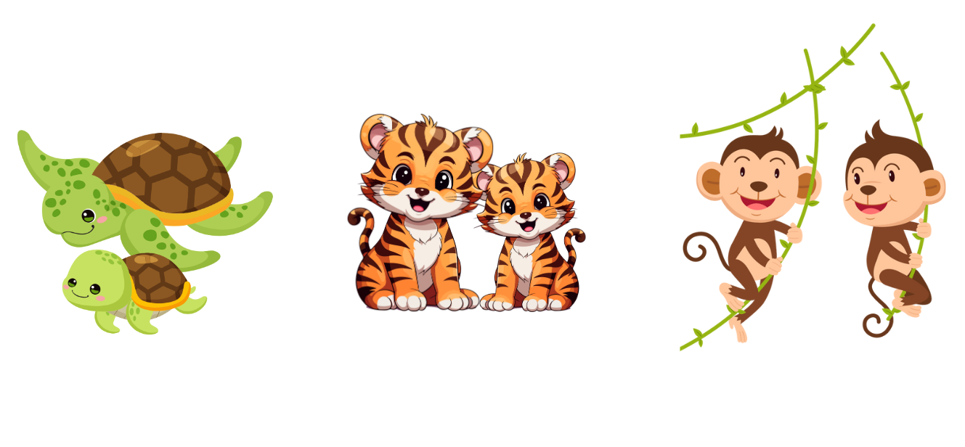
 | 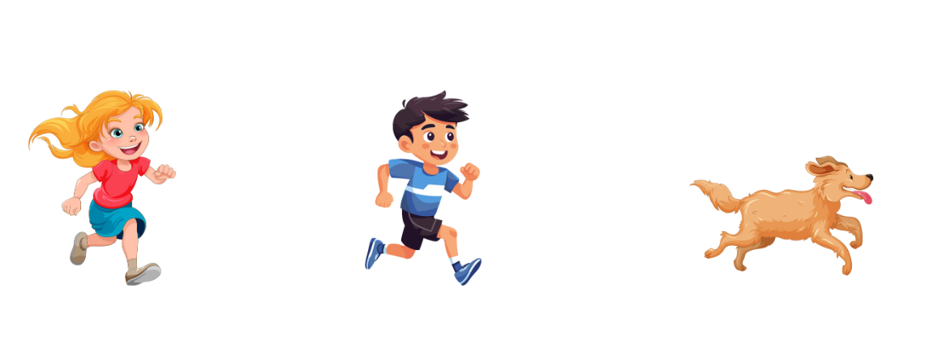
 | 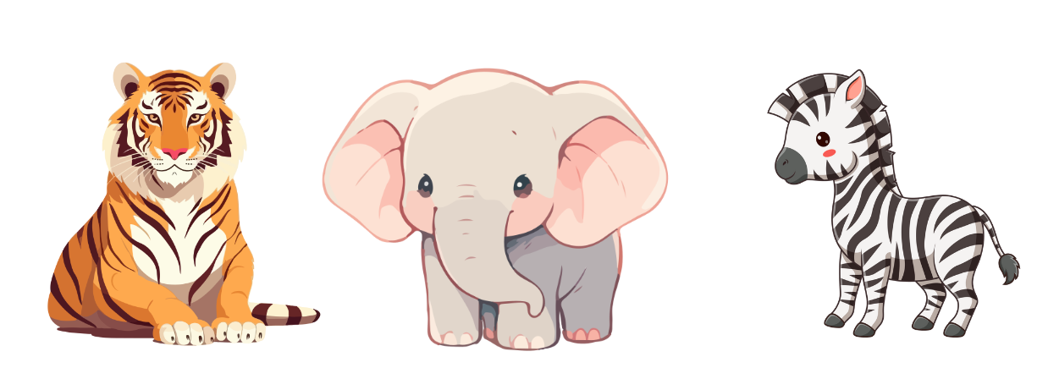
 | 
 | 
 |  | Listen and tick or cross (1 point)


x
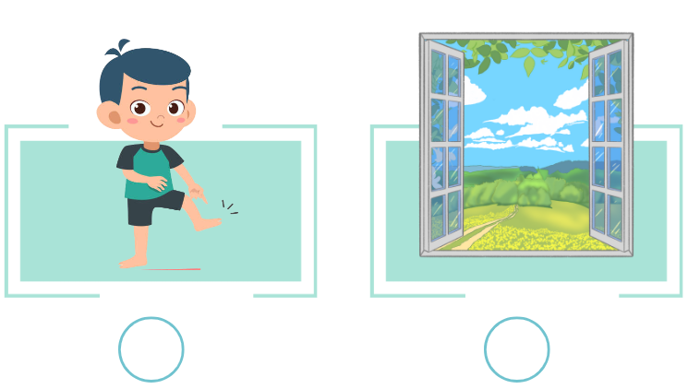

PART II. READING
 |  |  | Read and match (0.75 points)
 |   0. mother |  |  | 1. noodles |  | 2. sun |  | 3. tiger
 |  |  |  |  |  |  |  | 
 |  | Read and circle A, B or C (0.75 points)
- There are three tops.
-  |  |  |  |  | - 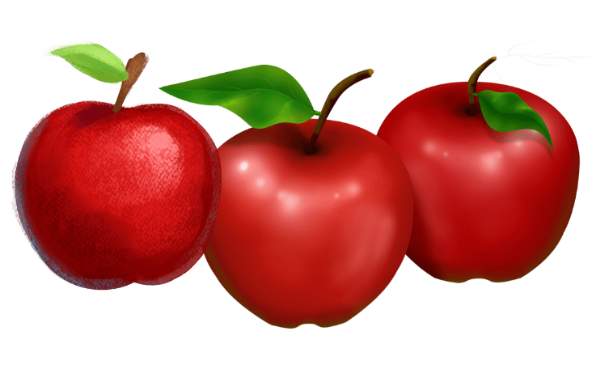 |  | - 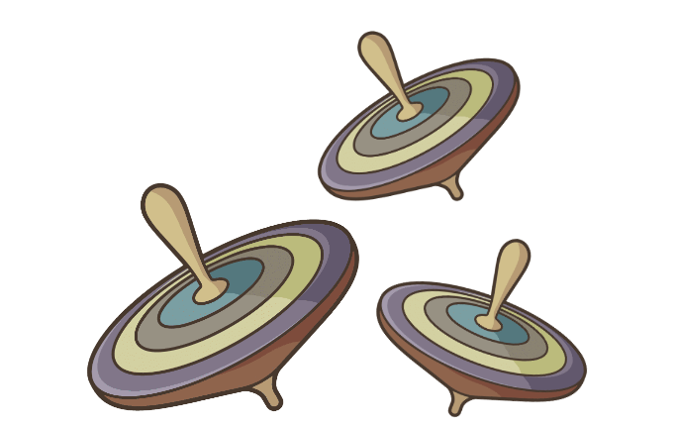
- She’s running.
-  |  |  |  |  | -  |  | - 
- He is watching football.
-  |  |  |  |  | -  |  | - 
- I can see a monkey.
-  |  |  |  |  | -  |  | - 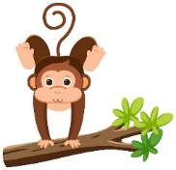
PART III. WRITING
 | Write the missing letters (1.5 points)


K
C
O
L
C
0

N
B
1


D
W
2

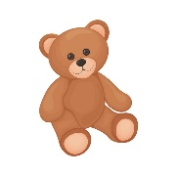
T
B
Y
D
3

 | Write the missing words (1.5 points)
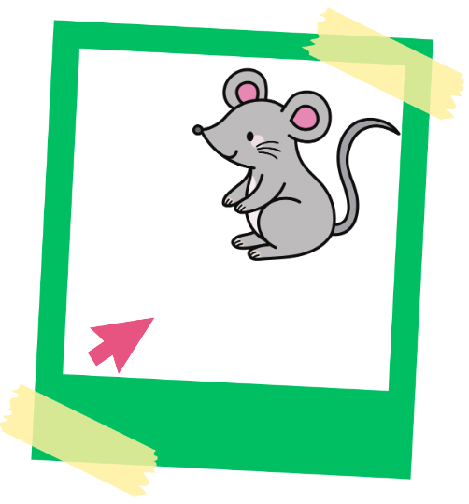 |  | 
- That’s a mouse. |  | - How many ____________ can you see?
 |  | 
- I can see a ____________. |  | - Look at the ____________.
PART IV. SPEAKING
 | Introduction (0.5 points)
Teacher asks students to answer questions:
- Hello, what’s your name?
- How are you today?
 | Let’s talk (2 points)
Teacher asks students to do actions:
Point to your head/ face/ hair/ hand/ foot.
ĐÁP ÁN

PART I. LISTENING
Listen and tick (1 point)

 |  | f | ✓ | m
 | ✓ | u |  | o |  |  |  | l | ✓ | n
 |  | n | ✓ | o |  |  | ✓ | l |  | t

Listen and circle (1 point)

 | 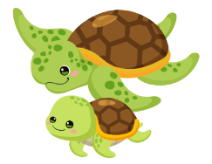 |  | 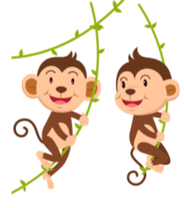
 |  |  | 
 |  | 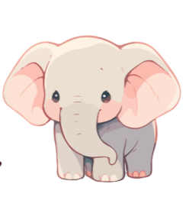 | 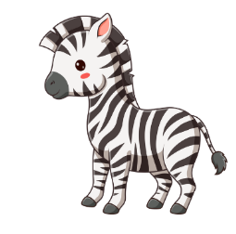
 |  | 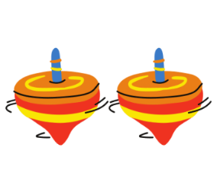 | 
 |  |  | 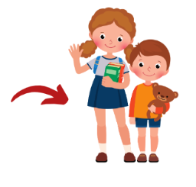

Listen and tick or cross (1 point)


x
 |   ✓ |  |   x
 | 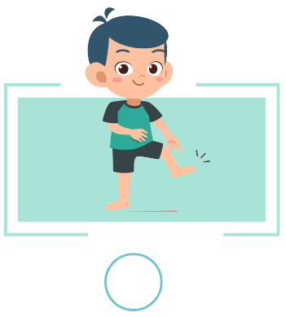  x |  | 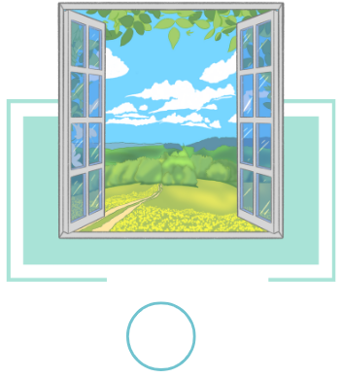  ✓

PART II. READING
 | Read and match (0.75 points)
  mother |  | noodles |   sun |   tiger
 |  |  |  | 

 | Read and circle A, B or C (0.75 points)
- There are three tops.
-  |  | - 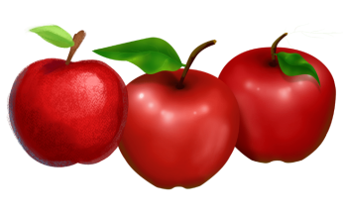 | - 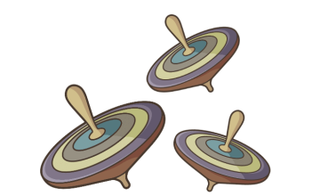
- She’s running.
-  |  | -  | - 
- He is watching football.
-  |  | -  | - 
- I can see a monkey.
-  |  | -  | - 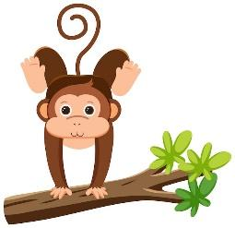
PART III. WRITING
Write the missing letters (1.5 points)

0
C
L
O
K
C

1
A
N
A
N
A
B

2
W
W
O
D
N
I
3
R
A
E
T
B
Y
D
D
E

 | Write the missing words (1.5 points)
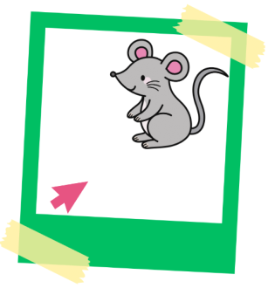 |  | 
- That’s a mouse. |  | - How many mops can you see?
 |  | 
- I can see a bus. |  | - Look at the mango.
PART IV. SPEAKING
Introduction (0.5 points)
- Hello, what’s your name?
- How are you today?
Let’s talk (2 points)
Teacher asks students to do actions:
Point to your head/ face/ hair/ hand/ foot.

