**Phòng Giáo dục và Đào tạo .....**

**Trường Tiểu học .....**

**Đề thi Học kì 2 Tiếng Anh lớp 5**

*(Bộ sách: Global Success)*

*Thời gian làm bài: .... phút*

**(Đề 1)**

**I. Choose the odd one out.**

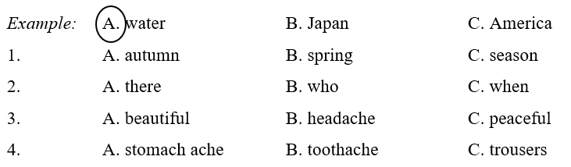

**II. Listen and circle.**

**Bài nghe:**

1. Steve likes summer best because ___________.

A. he can travel

B. he has summer vacation

C. he gets an examination

2. In the summer, Steve doesn’t have to go to school, do homework and ___________.

A. get an examination

B. do housework

C. get up early

3. He reads a lot of ___________ during summer vacation.

A. books

B. fairy tales

C. comics

4. He goes to the beach with ___________.

A. his friends

B. his cousins

C. his family

5. In the evening he ___________ or watches TV.

A. does the gardening

B. waters the flowers

C. plants flowers

**III. Read and choose the correct answers.**

1. What do you usually do ______ spring?

A. on

B. at

C. in

2. There ______ a lot of flowers at the festival last week.

A. were

B. are

C. was

3. ______ did they do yesterday?

A. When

B. What

C. Who

4. ______ you going to Nha Trang next week?

A. Do

B. Is

C. Are

5. Peter doesn’t want ______ football.

A. play

B. played

C. playing

**IV. Read the passage and write T (true) or F (false).**

Linda is from England. There are four seasons in her country. In summer, it is hot. She often goes swimming. In autumn, it is cool and wet. Her father and she sometimes go fishing. It is very cold in winter. They usually go skiing in the mountains. In spring, it is warm and beautiful. They often go camping in the national park.

|  |  |  |
| --- | --- | --- |
| **Sentences** | **T** | **F** |
| 1. Linda isn’t from England. |  |  |
| 2. There are five seasons in her country. |  |  |
| 3. Her father and she sometimes go fishing. |  |  |
| 4. They usually go skiing in the mountains. |  |  |
| 5. In spring, it is cool and beautiful. |  |  |

**V. Rearrange the words to make correct sentences**

1. in / summer / What / like / is / the / weather / ?

___________________________________________________

2. isn’t / going / to / Hoi An / Minh / next / week / .

___________________________________________________

3. is / it / here / your / house / How far / from / to / ?

___________________________________________________

**ANSWER KEY**

**I.**

1. C     2. A

3. B     4. C

**II.**

***Audio script:***

Hi! I'm Steve. It is summer now - the season I like best, because I have summer vacation. I feel very excited because I don't have to go to school, do homework, or get an examination. It's great!

It is the time for relaxation. How do I relax? I'll tell you. First of all, I read a lot of comics. I really love them. Then I feed rabbits in the garden, I bring them grass, cabbage and carrots. Then my family and I go to the beach. We swim and sunbathe there. It is such a pleasure. In the evening I water flowers and plants, or watch TV. I go to bed at around 11 p.m.

***Key:***

1. B    2. A

3. C     4. C    5. B

**III.**

1. C    2. A

3. B      4. C  5. A

**IV.**

1. T    2. F

3. T    4. T    5. F

**V.**

1. What is the weather like in summer?

2. Minh isn’t going to Hoi An next week.

3. How far is it from here to your house?