Phòng Giáo dục và Đào tạo .....
Trường Tiểu học .....
Đề thi Học kì 1 Tiếng Anh lớp 5
(Bộ sách: Global Success)
Thời gian làm bài: .... phút
(Đề 1)
I. Listen to the sounds and circle the correct words.
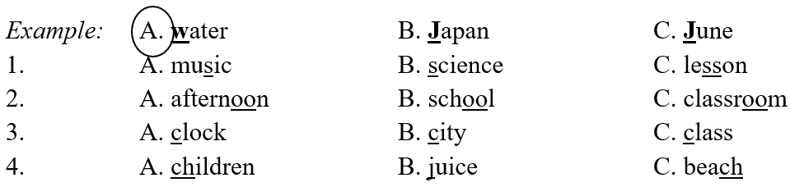
II. Listen and circle.
1.
a. This is my friend, Annie. She’s in Grade 5D.
b. My name’s Annie. I’m in Grade 5D.
c. Annie is my sister. She likes dolphins.
2.
a. There are 20 dolphins.
b. Yes, I do.
c. It’s 99 Oxford Street.
3.
a. He’s Janpanese.
b. He likes orange.
c. He’s helpful.
Pause
00:00
00:15
01:31
Mute
4.
a. She likes going for a walk.
b. She is watching a cartoon.
c. She has a lot of friends.
5.
a. Because I’d like to teach children
b. I’m cooking with my sister.
c. I’d like to be an artist.
III. Circle the correct answers.
Example: |  | Where is he from?  A. He’s from Thailand.  B. He’s from Malaysia.  
1. |  | What food do you have for breakfast?  A. I have pizza.  B. I have sandwich.  C. I have fish.
2. |  | What would she like to be in the future?  A. She’d like to be a firefighter.  B. She’d like to be a dentisr.  C. She’d like to be a teacher.
3. |  | Where is the notebook?  A. It’s in the school bag.  B. It’s on the table.  C. It’s under the table.
4. |  | What nationality are you?  A. I am Vietnamese.  B. I am American.  C. I am Japanese.
IV. Fill in the blanks.
This is my friend. Her name is Sue. She (1) ______ American. Sue is (2) ______. She likes playing (3) ______ in her free time. She usually goes swimming at weekend. Sue is (4) ______, too. She helps her mother with the (5) ______ in the evening. She somtimes helps me learn English. I am happy that I have a nice friend like Sue.
V. Rearrange the words to make correct sentences
1. table/ play/ Linda/ is/ tennis/ to/ going.
______________________________________
2. Day/ will/ be/ weekend/ Sport/ this/ ./
______________________________________
3. often/ do/ how/ have/ you/ your/ lesson/ favorite/ ?/
______________________________________
ANSWER KEY
I.
Audio script:
Example: /w/ /w/
Key:
1. C 2. C
3. B 4. B
II.
Audio script:
1. Can you tell me about yourself?
2. What’s your address?
3. What nationality is he?
4. What does she like doing in her free time?
5. What would you like to be in the future?
Key:
1. b 2. c 3. a
4. a 5. c
III.
1. B 2. A
3. B 4. A
IV.
1. is
2. active
3. table tennis
4. helpful
5. Cooking
V.
1. Linda is going to play table tennis.
2. Sport Day will be this weekend.
3. How often do you have your favorite lesson?
................................
................................
................................

