Phòng Giáo dục và Đào tạo .....
Đề thi chất lượng Học kì 1
Năm học 2024 - 2025
Bài thi môn: Tiếng Anh lớp 5
Thời gian làm bài: 45 phút
(Đề 5)
I. READING
Part 1: 1-6. Read and match
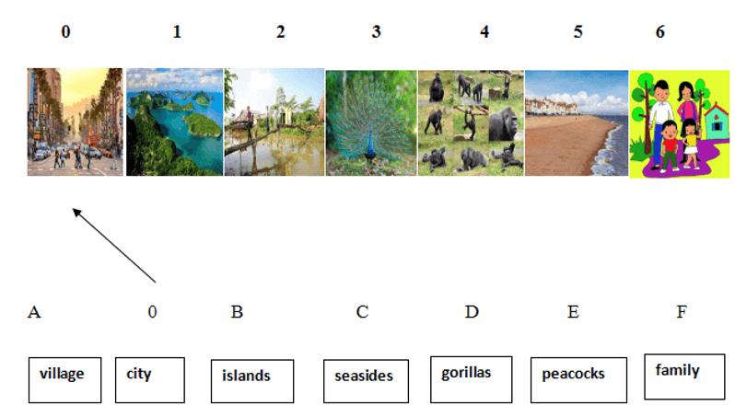
Part 2: 7-12. Read and tick true (T) or false (F)
My name is Nam. I’m in class 5B, Nguyen Du primary school. My school year started in August. I go to school every day except Saturday and Sunday. I have four lessons a day. Today is Wednesday I have Maths, Vietnamese, Music and English. I have Maths and Vietnamese every school day. I have Music once a week and English four times a week.
EXAMPLE. - His name is Nam (T)
- He’s in class 5B (F)
7. His school is Nguyen Du primary school.
8. His school year started in September.
9. He goes to school from Monday to Friday.
10. He has five lessons a day.
11. He has Maths and Vietnamese every school day.
12. He has English twice a week.
Part 3: 13-18. Reorder number the sentences to make a dialogue.
13. I hope I will go there this holiday.
14. The street was noisy and crowded but the food was delicious.
15. I went to Ho Chi Minh city.
16. Yes, I will.
17. What do you think of it?
18. Will you go there again?
0 - What do you do last weekend?
Your answer: _____________________________
Part 4: 19-25. Read and complete.
four | emails | practise | Monday | M | Vietnamese | because | TV
Hello. My name is (0) Minh. I go to school from (19)______ to Friday. I have Maths and (20)__________ every school day. I have English (21)_______ times a week. English is my favourite subject. I (22)_______ reading by reading English comic books. Every day I practise writing English by sending (23)_________ to my friend Ha lim in Malaysia. I learn English (24) __________ I want to watch English cartoons on (25) ______.
II. WRITING
Part 1: 1-6. Fill in the blank.
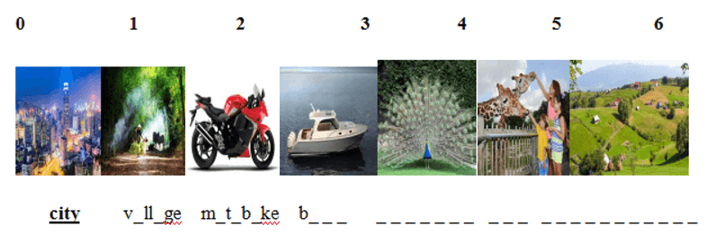
Part 2: 7-13. Reorder the words to make sentences.
Example. early. / up / always / I / get
- I always get up early.
7. did/ on/ do/ holiday?/ you/ What
_____________________________
8. lessons/ How/ today?/ many/ have/ you/ do
_______________________________________
9. English/ every/ speak/ day./ I
_______________________________
10. reading/ of/ the/ I’m/story/ Mai An Tiem.
_______________________________________________
11. fast./ They/ really/ were
__________________________________________________
12. play/ I’m/ to/ going/ badminton.
______________________________________________
Part 3: 13-18. Read and complete.
My name is Nam. It was my birthday last Sunday. I invited some of my classmates to the party. They gave me presents like comic books, robots and teddy bear. We ate cakes, sweets, fruit and ice-cream. We drank fruit juice. We sang English and Vietnamese songs. We dance, too. Phong played the guitar and Linda played the piano. The party ended at 7 p.m. We enjoyed it very much.
13. What is his name?
_______________________
14. When was Nam’s birthday party?
________________________________
15. Who went to Nam’s birthday party?
_________________________________
16. What did Phong do at the party?
________________________________
17. What did Linda do at the party?
__________________________________
18. What time did the party end?
______________________________________
Part 4: 19-25. Write about you.
19. What’s your name? _________________
20. How old are you? ______________________
21. Where do you live? _________________________________
22. Who do you live with? ____________________________
23. Where did you go last holiday? __________________________
24. How do you learn English? ________________________________
25. How do you practice speaking English? ________________________________

Đáp án & Thang điểm
I. READING
Part 1. Read and match
1. C | 2. A | 3. F | 4. E | 5. D | 6. G
Part 2. Read and tick
7. F | 8. T | 9. F | 10. T | 11. T | 12. F
Part 3. Reorder the number to make a dialogue
15 – 17 – 14 – 18 – 16 - 13
Part 4. Read and complete.
19. Monday | 20. Vietnamese | 21. four | 22. practice
23. emails | 24. because | 25. TV
II. WRITING
Part 1. Read and complete
1. village | 2. motorbike | 3. boat
4. peacock | 5. zoo | 6. countryside
Part 2. Reorder the words to make sentences.
7. Where did you go on holiday?
8. How many lessons do you have today?
9. I speak English every day.
10. I am reading the story of Mai An Tiem.
11. They were really fast.
12. I am going to play badminton.
Part 3. Read and complete.
13. His name is Nam.
14. It was last Sunday.
15. Phong and Linda went to Nam’s birthday party.
16. Phong played the guitar
17. Linda played the piano
18. The party ended at 7 p.m.
Part 4. Write about you. (ĐÂY LÀ MẪU)
19. My name…….
20. I’m……. years old.
21. I live in……
22. I live with……..
23. I went to…….
24. Because I want to ……..
25. I speak English with………………….

