Phòng Giáo dục và Đào tạo .....
Trường Tiểu học .....
Đề thi Học kì 1 Tiếng Anh lớp 4
(Bộ sách: Global Success)
Thời gian làm bài: .... phút
(Đề 1)
Listening
Câu 1 : Listen and number.
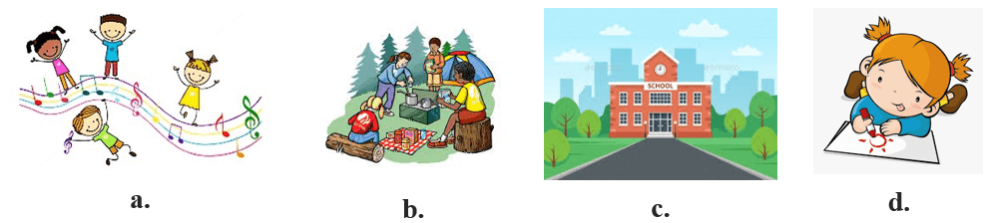
1.

2.
3.
4.
5.
Câu 2 : Con hãy ghép đáp án ở cột A với đáp án tương ứng ở cột B
Listen and match.
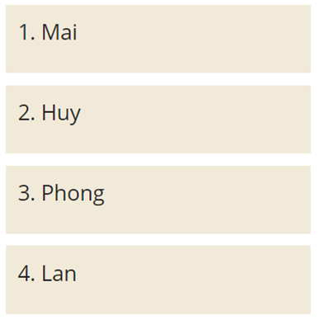 | 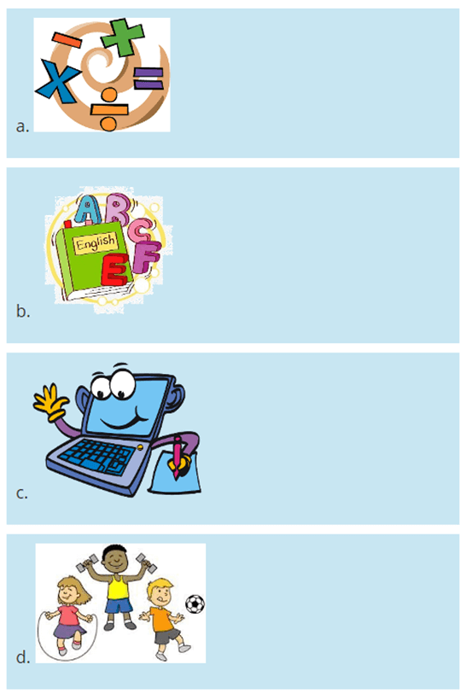
Câu 3 : Listen and complete.
1. Is your sports day in
? - Yes, it is.
2. How many
are there at your school? - There is one.
3. Why do you like
? - Because I want to be a singer.
4. Where were you last summer? – I was in
.
Reading and Writing
Câu 1 : Read and choose A, B or C.
Câu 1.1 : 1. When do you have art?

A. It’s in September.
B. I have it on Tuesdays.
C. I like art.
Câu 1.2 : 2. Where’s your school?

A. It’s in the village.
B. I was at the beach.
C. I study at school.
Câu 1.3 : 3. Why do you like maths?

A. I have it on Mondays.
B. My favourite subject is maths.
C. Because I want to be a maths teacher.
Câu 1.4 : 4. Were you in the countryside last month?

A. No, I was.
B. Yes, I was.
C. Yes, I were.
Câu 1.5 : 5. Is your sports day in September?
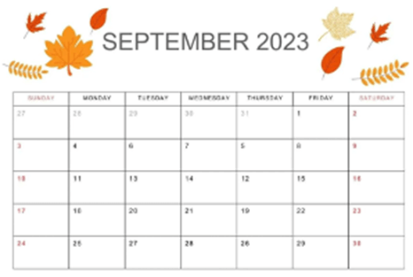
A. Yes, it isn’t.
B. No, it isn’t.
C. Yes, it is.
Câu 2 : Choose the correct answer.
Câu 2.1 : 1. What does he want _______?
A. eat
B. to eat
C. eating
Câu 2.2 : 2. How many _________ in your school?
A. classrooms
B. classroom
C. some classrooms
Câu 2.3 : 3. Jane and John ________ from America.
A. is
B. are
C. am
Câu 2.4 : 4. I get up ________ 6 A.M.
A. on
B. in
C. at
Câu 3 : Read and decide each sentence below is T (True) or F (False).
My name is Mark. I had a great summer. I went camping with my sister Susan in Green Park. We went camping because it was my sister’s birthday and she liked outdoor activities. We stayed there for five days. We went fishing, hiking and swimming every day. It was a wonderful summer.
Câu 3.1 : 1. Mark went camping with her friend.
A. T
B. F
Câu 3.2 : 2. They went camping in Green Park.
A. T
B. F
Câu 3.3 : 3. Susan likes indoor activities.
A. T
B. F
Câu 3.4 : 4. They stayed for 5 days.
A. T
B. F
Câu 3.5 : 5. They went fishing, hiking and swimming every day.
A. T
B. F
Câu 4 : Read and complete. Use the given words.
lemonade sandcastle ball swim beach
Hello, my name is Sam. I like to go to the (1) _____ in summer. I (2) ____________ in the sea and build a (3) ____________. I look for shells and throw a (4) _____________ at the beach. I drink (5) ____________ and eat an ice cream. I like my summer holidays!
1.
2.
3.
4.
5.
Câu 5 : Reorder the words to make correct sentences.
1. sports / My / is / day / March / in /.
2. many / at / school / buildings / How / your / there / are / ?
3. on / have / I / music / Tuesdays / .
4. you / were / Where / summer / last / ?

Đáp án
Listening
Câu 1:
1. a | 2. d | 3. b | 4. c
Câu 2:
1. b | 2. d | 3. c | 4. a
Câu 3:
1. September | 2. garden | 3. music | 4. Sydney
Reading and Writing
Câu 1:
Câu 1.1 : 1. Đáp án: B
Câu 1.2 : 2. Đáp án: A
Câu 1.3 : 3. Đáp án: C
Câu 1.4 : 4. Đáp án: B
Câu 1.5 : 5. Đáp án: C
Câu 2:
Câu 2.1 : 1. Đáp án: B
Câu 2.2 : 2. Đáp án: A
Câu 2.3 : 3 Đáp án: B
Câu 2.4 : 4. Đáp án: C
Câu 3:
Câu 3.1 : 1. Đáp án: B
Câu 3.2 : 2. Đáp án: A
Câu 3.3 : 3. Đáp án: B
Câu 3.4 : 4. Đáp án: A
Câu 3.5 : 5. Đáp án: A
Câu 4:
1. beach
2. swim
3. sandcastle
4. ball
5. lemonade
Câu 5:
1. My sports day is in March.||My sports day is in March
2. How many buildings are there at your school?||How many buildings are there at your school
3. I have music on Tuesdays.||I have music on Tuesdays
4. Where were you last summer?||Where were you last summer
Phòng Giáo dục và Đào tạo .....
Trường Tiểu học .....
Đề thi Học kì 1 Tiếng Anh lớp 4
(Bộ sách: Global Success)
Thời gian làm bài: .... phút
(Đề 2)
Listening
Câu 1 : Listen and number.
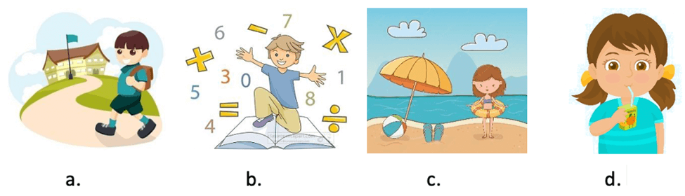
1.
2.
3.
4.
Câu 2 : Con hãy ghép đáp án ở cột A với đáp án tương ứng ở cột B
Listen and match.
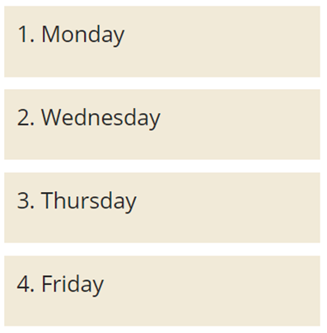 | 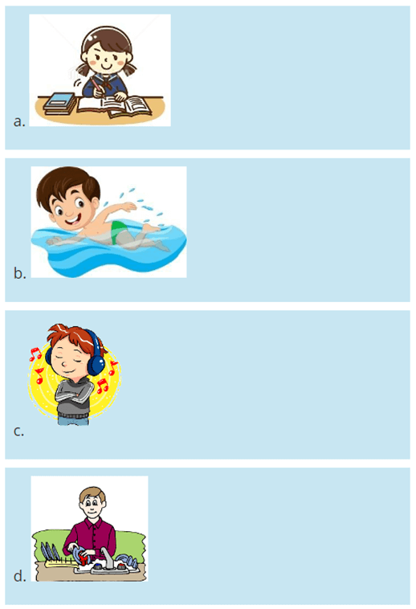
Câu 3 : Listen and complete.
1. When’s your birthday? – It’s in
.
2. Where’s your school? - It's in the
.
3. Why do you like
? - Because I want to be a painter.
4. Were you at the
last weekend? - Yes, I was.
Reading and Writing
Câu 1 : Read and choose A, B or C.
Câu 1.1 : 1. What time do you have lunch?

A. I have lunch at twelve fifteen.
B. I have lunch at half past twelve.
C. I have lunch at twelve o’clock.
Câu 1.2 : 2. Where were you last month?

A. I was in Tokyo.
B. I were in Tokyo.
C. I was on Tokyo.
Câu 1.3 : 3. What subject do you have today?

A. I have Vietnamese.
B. I have maths.
C. I have science.
Câu 1.4 : 3. How many playgrounds are there at your school?
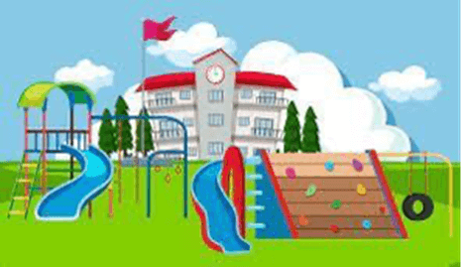
A. There are one.
B. There is one playgrounds.
C. There is one.
Câu 1.5 : 5. What does he do on Sunday?
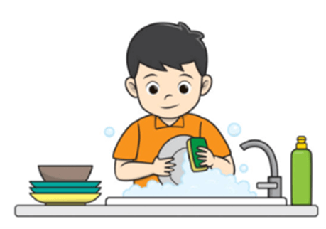
A. He does his homework.
B. He listen to music
C. He does housework.
Câu 2 : Choose the correct answer.
Câu 2.1 : 1. Is your sports day ______ July?
A. in
B. om
C. at
Câu 2.2 : 2. _______ you at the beach last wekeend?
A. Are
B. Was
C. Were
Câu 2.3 : 3. ________ do you have breakfast? – I have breakfast at 7.00 in the morning.
A. What
B. What time
C. How
Câu 2.4 : 4. Can you _____?
A. cook
B. cooking
C. cooks
Câu 3 : Read and decide each sentences below is T (True) or F (False).
This is Jack. He is my best friend. He is from Australia. He has been in Thailand for two years. He has two older brothers. They all live in a big house in Bangkok. Jack and his brothers go to the beach in the summer. They play beach ball or go swimming. Jack is very strong and he can swim fast.
Câu 3.1 : 1. Jack is from Thailand.
A. T
B. F
Câu 3.2 : 2. Jack has two older brothers.
A. T
B. F
Câu 3.3 : 3. Jack goes to the beach in the summer.
A. T
B. F
Câu 3.4 : 4. Jack is weak.
A. T
B. F
Câu 3.5 : 5. Jack can swim fast.
A. T
B. F
Câu 4 : Read and complete. Use the given words.
classrooms eat playground garden school
Hi, I’m Sue. I’m 7 years old. This is my (1) ________. It’s not big but it’s beautiful. There are twenty (2) ___________ in my school. There is a small (3) ____________. We often run and play there at break time. There is also a (4) _________. We plant trees and flowers there. We (5) ___________ at the school canteen.
1.
2.
3.
4.
5.
Câu 5 : Write suitable answers to the questions, using the words in the brackets.
1. Where’s your school? (city)
2. Why do you like maths? (maths teacher)
3. What subjects do you have today? (English and art)
4. When do you have science? (Tuesdays)
Đáp án
Listening
Câu 1:
1. d | 2. c | 3. b | 4. a
Câu 2:
1. a | 2. c | 3. d | 4. b
Câu 3:
1. September | 2. mountains | 3. art | 4. campsite
Reading and Writing
Câu 1:
Câu 1.1 : 1. Đáp án: B
Câu 1.2 : 2. Đáp án: A
Câu 1.3 : 3. Đáp án: C
Câu 1.4 : 4. Đáp án: C
Câu 1.5 : 5. Đáp án: C
Câu 2:
Câu 2.1 : 1. Đáp án: A
Câu 2.2 : 2. Đáp án: C
Câu 2.3 : 3 Đáp án: B
Câu 2.4 : 4. Đáp án: A
Câu 3:
Câu 3.1 : 1. Đáp án: B
Câu 3.2 : 2. Đáp án: A
Câu 3.3 : 3. Đáp án: A
Câu 3.4 : 4. Đáp án: B
Câu 3.5 : 5. Đáp án: A
Câu 4:
1. school
2. classrooms
3. playground
4. garden
5. eat
Câu 5:
1. It’s in the city.||It’s in the city
2. Because I want to be a maths teacher.||Because I want to be a maths teacher
3. I have English and art.||I have English and art||Today I have English and art.||Today I have English and art
4. I have science on Tuesdays||I have science on Tuesdays

