School ...............……  Class: 4.1  Name: ………………… | THE FIRST SEMESTER TEST  ENGLISH - CLASS 4  School year: 2024 – 2025  Duration: 35 minutes
LISTENING
PART 1: Listen and tick. There is one example.(1pt)
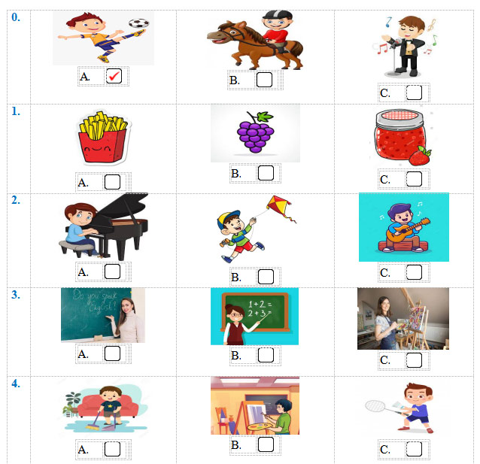
PART 2: Listen and number. There is one example.(1pt)
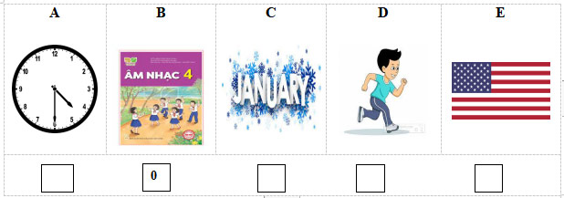
PART 3: Listen and draw line. There is one example. (1pt)
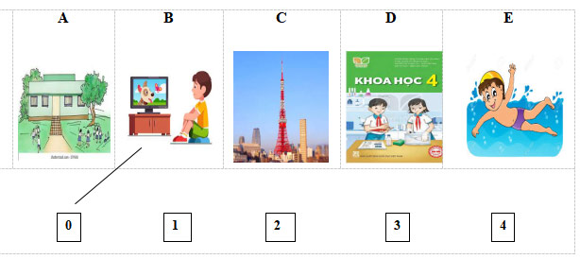
PART 4: Listen and write. There is one example.(1pt)
0. He’s at the zoo at weekends.
1. There’s some …………………. on the table.
2. He’s from ……………………………
3. What day is it today? – It’s ……………………..
4. My favourite subject is………..…………………
READING
PART 1: Read and match the words with pictures. There is one example. (1pt)
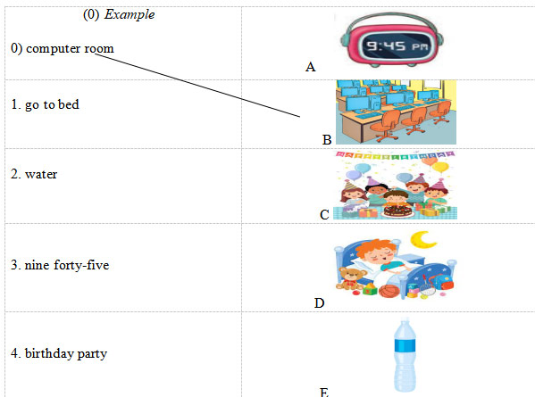
PART 2. Read and choose A, B or C to complete text. There is one example. (1pt)
Hello, My name is Hoa. I’m from (0 ……… I was on holiday in Nha Trang last summer. The beach was very beautiful. We went(1)……………….……… in the sea and then built sandcastles in the afternoon.
In the evening, we had seafood at a restaurant, it was excellent. The people were friendly (2)………………….helpful. We also watched a film at the (3)………………., it was interesting. My holiday was very nice.
0. a. English b. Vietnamese c. Viet Nam
1. a. swimming b. singing c. cooking
2. a. of b. and c. on
3. a. mountain b. hospital c. cinema
PART 3. Read and tick (√) True or False. There is an example .(1.0 pt )
Hung is a pupil at Quang Trung Primary school. Every day he gets up at 6 o’clock. He has breakfast at six twenty and goes to school at six forty- five. School starts at 7:00 a.m and finishes at 10:30 a.m. He goes home at 10: 45. He has lunch at 11.15. In the afternoon, he often plays football with his friends at 4:00. In the evening he does his homework or listens to music. Then, he goes to bed at 9:30.
 |  | TRUE | FALSE
0. | 0. Hung is a pupil at Quang Trung Primary school.
1. | 1. He has breakfast at 6: 25.
2. | 2. School starts at seven a.m and finishes at ten thirty a.m.
3 | 3. In the evening, he does his housework or listens to music.
WRITING
PART 1. Look at the pictures and the letters. Write the words. (2.0 pts)
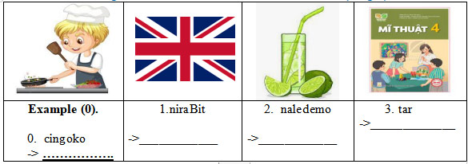
PART 2. Rearrange the words to make the sentences. There is one example. (2.0pt)
0. day/ your/When’s /sports /?/
→ ……………………………………………………………………………………………
2. five/ I/ at/ get/ thirty / up /./
………………………………………………………………………………………
3. subject/your / What’s /favourite/ ? /
………………………………………………………………………………………
4. do/on/ I/ Sunday/ housework/./
………………………………………………………………………………………

1.2. Đáp án đề thi học kì 1 môn Tiếng Anh 4 Global Success
LISTENING
PART 1. (0,25*4 =1pt)
1.B 2.C 3.A 4.B
PART 2. (0,25*4 =1pt)
1.E 2.A 3.D 4.C
PART 3. (0,25*4 =1pt)
1.E 2.D 3.C 4.A
PART 4. (0,25*4 =1pt)
1 jam 2 Australia 3. Friday 4 Maths
READING
PART 1 (0,25*4 =1pt)
1.D 2. E 3. A 4.C
PART 2 (0,25*3 =0.75 pts )
1. A 2. B 3. C
PART 3 (0,25*3 =0.75 pts )
1. TRUE 2. TRUE 3. FALSE
WRITING
PART 1 (0,25*3 =0.75 pts )
1. Britain 2.lemonade 3. art
PART 2 (0,25*3 =0.75 pts )
1. I get up at five thirty.
2. What’s your favourite subject?
3. I do housework on Sunday.
SPEAKING
Greeting & test taker’s name check.
The examiner says “My name is…It’s nice to talk to you today.”
Part 1: Getting to know each other
The examiner asks 3 questions below:
1. What’s your name?
2. Where are you from?
3. What’s your favourite subject?
Part 2: Point at the picture and say the words / sentences
The examiner point to the pictures and ask ss some questions.
1. What time is it?
2. Can he/ she…………..?
3. How many……………….are there at the school?
4. Is sports day in…………..?
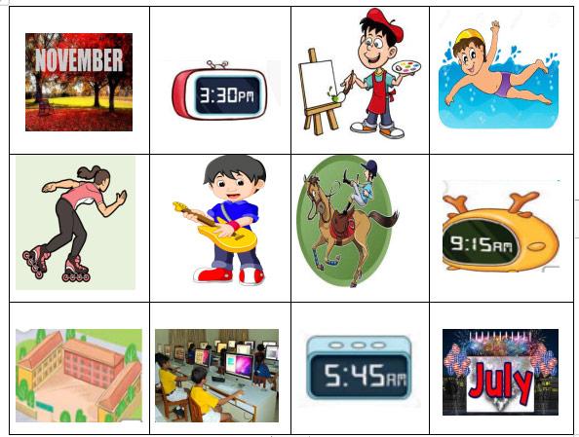
Part 3: Answer the questions:
The examiner asks 3 questions below:
1. What time do you……………?
2. What do you want to eat/ drink?
3. When’s your birthday?
That’s the end of the speaking test. You did a great job. Thank you.

1.3. Ma trận đề thi học kì 1 môn Tiếng Anh 4 Global Success
Kỹ năng | Nhiệm vụ đánh giá/kiến thức cần đánh giá | Mức/Điểm |  |  | Tổng số câu, số điểm, tỷ lệ %
Nghe | Nhiệm vụ đánh giá/kiến thức cần đánh giá | M1 | M2 | M3 | 16 câu  4 điểm  40%
Nghe | Listen and tick  Grapes, play the guitar, English teacher, brother | 2  0,5đ | 1  0,25đ | 1  0,25đ | 16 câu  4 điểm  40%
Nghe | Listen and number  America, four thirty, running, January | 1  0,25 | 1  0,25 | 2  0,5đ | 16 câu  4 điểm  40%
Nghe | Listen and draw the line  Swim, Science, Tokyo, village | 2  0,5đ | 1  0,25 | 1  0,25 | 16 câu  4 điểm  40%
Nghe | Listen and write  Jam, Australia, Friday, maths | 1  0,25 | 2  0,5đ | 1  0,25 | 16 câu  4 điểm  40%
Đọc | Read and match the words with the pictures  Go to bed, water, nine forty-five, birthday | 1  0,25 | 2  0,5 | 1  0,25 | 10 câu  2 điểm  2,5%
Đọc | Read and choose A, B or C to complete sentences.  Cinema, swimming, and | 1  0,25 | 1  0,25đ | 1  0,25 | 10 câu  2 điểm  2,5%
Đọc | Read and tick True or False  Six twenty/ have breakfast, seven a.m and ten thirty a.m | 2  0,5 | 1  0,25đ |  | 10 câu  2 điểm  2,5%
Viết | Look at the pictures and the letters. Write the words  Britain, lemonade, art | 1  0,25đ | 2  0,5đ |  | 6 câu  1,5 điểm  15%
Viết | Rearrange the words to make the sentences  - I get up at five thirty.  - What’s your favourite subject?  - I do housework on Sunday. | 1  0,25đ | 1  0,25đ | 1  0,25đ | 6 câu  1,5 điểm  15%
Nói | Getting to know each other  What’s your name?/Where are you from? /What’s your favourite subjects? |  | 2  0,5đ | 1  0,25đ | 8 câu  2 điểm  20%
Nói | Point at the picture and say the words / sentences  The examiner point to the pictures and ask ss some questions.  What time is it? / Can he/ she…..?/How many……….are there at the school?/ Is sports day in…………..? |  | 1  0,75đ | 1  0,25đ | 8 câu  2 điểm  20%
Nói | Answer the questions: The examiner asks 3 questions below:  What time do you……………? What do you want to eat/ drink? When’s your birthday? | 1  0,25đ | 1  0,25đ | 1  0,25đ | 8 câu  2 điểm  20%
Tổng |  | 13 – 32,5% | 16– 40% | 11 – 27,5% | 40câu –10 điểm/  100%

2. Đề thi học kì 1 môn Tiếng Anh 4 Kết nối tri thức - Đề 2

2.1. File nghe đề thi học kì 1 môn Tiếng Anh 4

2.2. Đề thi học kì 1 môn Tiếng Anh 4
LISTENING
PART 1: Listen and tick. There is one example. (1pt)
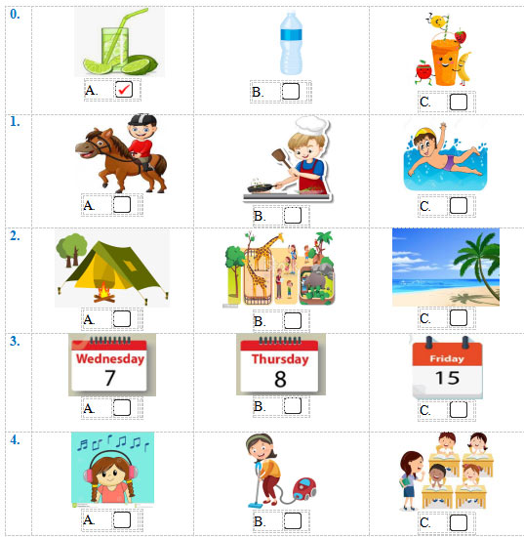
PART 2: Listen and number. There is one example. (1pt)
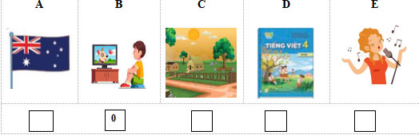
PART 3: Listen and draw line. There is one example. (1pt)
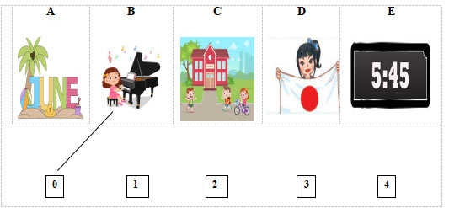
PART 4: Listen and write. There is one example.(1pt)
0. I study at school.
1. I’m from ………………………
2. I want to be a ………………… teacher.
3. He likes ……………………..
4. When’s your birthday? – It’s in ………..……………
READING
PART 1: Read and match the words with pictures. There is one example. (1pt)
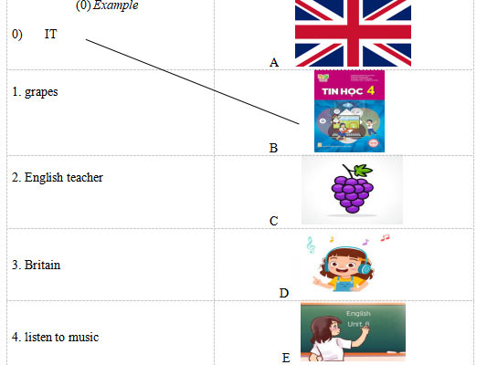
PART 2. Read and choose A, B or C to complete text. There is one example. (0,75pts)
There are four people in my (0) family. My father (1)……………….…… swim very well. My mother can cook but she can’t (2)……………….… the piano. My brother can play football and play the guitar but he can’t dance. I like music, I can sing (3)………… dance but I can’t cook.
0.a. friend b. teacher c. family
1. a. do b. can c. is
2. a. play b. does c. do
3. a. on b. to c. and
PART 3 .Read and tick (√) True or False. There is an example .(0,75pts)
Hello. My name is Lucy. It is Wednesday today. It is a school day. My friend Mary and I go to school on Mondays, Tuesdays, Wednesdays, Thursdays and Fridays. At the weekend, we stay at home. We do housework on Saturdays. We listen to music and watch TV on Sundays.
 |  | TRUE | FALSE
0. | 0. Today is Wednesday. | √
1. | 1. Mary and Lucy goes to school from Mondays to Fridays.
2. | 2. At the weekend, they don’t stay at home.
3 | 3. On Saturdays, they do homework.
WRITING
PART 1. Look at the pictures and the letters. Write the words. (0,75pts)
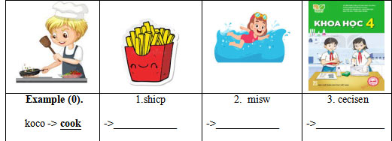
PART 2. Rearrange the words to make the sentences. There is one example. (0,75pts)
(0). is/ What/ time/ it /?/
→ What time is it?
1. six/ I/ at/ breakfast/ have/ fifteen/./
………………………………………………………………………………………
2. want/ do/ What/ to/ you/ eat/ ? /
………………………………………………………………………………………
3. school/ has/ My/ playground/ a/./
………………………………………………………………………………………
SPEAKING. (2pts)
Part 1
Part 2
Part 3

2.3. Đáp án đề thi học kì 1 môn Tiếng Anh 4
ĐÁP ÁN VÀ BIỂU ĐIỂM BÀI KIỂM TRA ĐỊNH KỲ HỌC KÌ I
MÔN TIẾNG ANH LỚP 4 – NĂM HỌC 2024-2025
LISTENING
PART 1. (0,25*4 =1pt)
1.B 2.A 3.C 4.B
PART 2. (0,25*4 =1pt)
1.D 2.A 3.E 4.C
PART 3.(0,25*4 =1pt)
1. A 2. E 3. C 4. D
PART 4. (0,25*4 =1pt)
1. America 2. Maths 3. running 4. January
READING
PART 1 (0,25*4 =1pt)
1.C 2. E 3. A 4.D
PART 2 (0,25*3 =0.75 pts )
1. B 2. A 3. C
PART 3 (0,25*3 =0.75 pts )
1. TRUE 2. FALSE 3. FALSE
WRITING
PART 1 (0,25*3 =0.75 pts )
1. chips 2.swim 3. Science
PART 2 (0,25*3 =0.75 pts )
1. I have breakfast at six fifteen.
2. What do you want to eat?
3. My school has a playground.
SPEAKING
Greeting & test taker’s name check.
The examiner says “My name is…It’s nice to talk to you today.”
Part 1: Getting to know each other
The examiner asks 3 questions below:
1. What’s your name?
2. What time is it?
3. Where are you from?
Part 2: Point at the picture and say the words / sentences
The examiner point to the pictures and ask ss some questions.
1. Can he/ she…………..?
2. Where’s he/ she from?
3. Is sports day in…………..?
4. Why do you like………….?
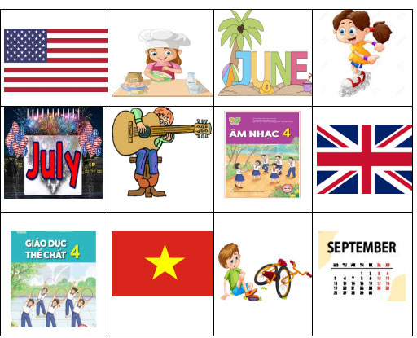
Part 3: Answer the questions:
The examiner asks 3 questions below:
1. What do you want to eat/ drink?
2. When’s your birthday?
3. What do you do on………….?
That’s the end of the speaking test. You did a great job. Thank you.

2.4. Ma trận đề thi học kì 1 môn Tiếng Anh 4
Kỹ năng | Nhiệm vụ đánh giá/kiến thức cần đánh giá | Mức/Điểm |  |  | Tổng số câu, số điểm, tỷ lệ %
Nghe | Nhiệm vụ đánh giá/kiến thức cần đánh giá | M1 | M2 | M3 | 16 câu  4 điểm  40%
Nghe | Listen and tick  Cook, campsite, Friday, do housework | 2  0,5đ | 1  0,25đ | 1  0,25đ | 16 câu  4 điểm  40%
Nghe | Listen and number  Vietnamese, Australia, singer, village | 1  0,25 | 1  0,25 | 2  0,5đ | 16 câu  4 điểm  40%
Nghe | Listen and draw the line  June, five forty-five, go to school, Japan | 2  0,5đ | 1  0,25 | 1  0,25 | 16 câu  4 điểm  40%
Nghe | Listen and write  America, Maths, running, January | 1  0,25 | 2  0,5đ | 1  0,25 | 16 câu  4 điểm  40%
Đọc | Read and match the words with the pictures  English teacher, grapes, Britain, listen to music | 1  0,25 | 2  0,5 | 1  0,25 | 10 câu  2 điểm  2,5%
Đọc | Read and choose A, B or C to complete sentences.  Can, play, and | 1  0,25 | 1  0,25đ | 1  0,25 | 10 câu  2 điểm  2,5%
Đọc | Read and tick True or False  From Mondays to Fridays, stay at home, do housework | 2  0,5 | 1  0,25đ |  | 10 câu  2 điểm  2,5%
Viết | Look at the pictures and the letters. Write the words  Chips, science, swim | 1  0,25đ | 2  0,5đ |  | 6 câu  1,5 điểm  15%
Viết | Rearrange the words to make the sentences  - I have breakfast at six fifteen.  - What do you want to eat?  - My school has a playground. | 1  0,25đ | 1  0,25đ | 1  0,25đ | 6 câu  1,5 điểm  15%
Nói | Getting to know each other  What’s your name?/ What time is it? Where are you from? |  | 2  0,5đ | 1  0,25đ | 8 câu  2 điểm  20%
Nói | Point at the picture and say the words / sentences  The examiner point to the pictures and ask ss some questions.  Can he/ she…..?/Wher’s he/ she from?/ Why do you like…..?/ Is sports day in…………..? |  | 1  0,75đ | 1  0,25đ | 8 câu  2 điểm  20%
Nói | Answer the questions: The examiner asks 3 questions below:  What do you want to eat/ drink? When’s your birthday? / What do you do on……? | 1  0,25đ | 1  0,25đ | 1  0,25đ | 8 câu  2 điểm  20%
Tổng |  | 13 – 32,5% | 16– 40% | 11 – 27,5% | 40câu –10 điểm/  100%

