**Phòng Giáo dục và Đào tạo .....**

**Trường Tiểu học .....**

**Đề thi Giữa kì 2 Tiếng Anh lớp 3 Global Success**

*(Bộ sách: Kết nối tri thức với cuộc sống)*

*Thời gian làm bài: .... phút*

**(Đề 1)**

**I. Choose the odd one out**

|  |  |  |  |
| --- | --- | --- | --- |
| 1. A. school | B. living room | C. kitchen | D. bedroom |
| 2. A. father | B. mother | C. aunt | D. teacher |
| 3. A. between | B. in | C. on | D. upstairs |

**II. Look at the picture and write**

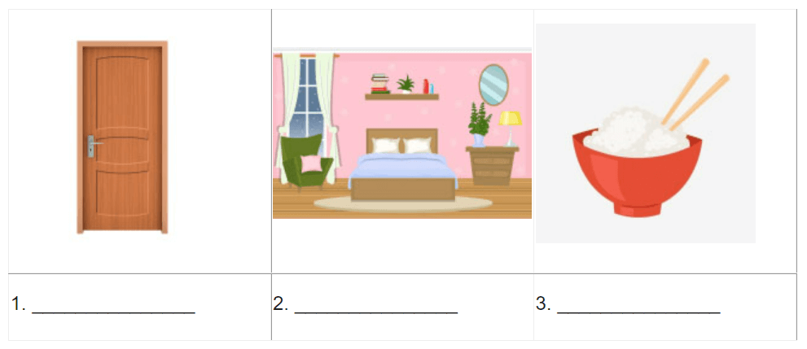

**III. Choose the best answer**

1. The coat is ………………. on the desk. It’s on the chair.

A. not

B. aren’t

C. isn’t

2. ….……….. you like some milk? - No, thanks.

A. What

B. Where

C. Would

3. Would you like some …………?

No, thanks. I’d like some drink.

A. drink

B. food

C. thing

4. A: Is there a fence around your house?

B: No, there …………..

A. is

B. aren’t

C. isn’t

5. How ………….. books are there on the table?

There are three books

A. much

B. very

C. many

**IV. Under and corrrect the mistakes**

1. He doesn’t have a balloon. He have a car.

….…………………………………………………………….

2. Does they have books?

….…………………………………………………………….

**V. Read the text and answer the questions**

I am Robert. This is a photo of my family. This is my father. He is forty-two years old. He likes reading news. This is my mother. She is thirty-five years old. She is a housewife. She likes cooking. This is my brother. His name is Jack. Jack is only two years old. This is my sister. Her name is Ann. She is eight years old. I am eleven years old. I love my family.

1. How old is Robet’s father?

….…………………………………………………………….

2. What does his mother like doing?

….…………………………………………………………….

3. What is his mother’s job?

….…………………………………………………………….

4. How old is Jack?

….…………………………………………………………….

5. How old is Robert?

….…………………………………………………………….

**VI. Reorder the words to make meaningful sentences**

1. old/ his/ How/ is/ sister/?/

….…………………………………………………………….

2. years/ father/ Her/is/old/ forty -three /./

….…………………………………………………………….

3. brother/ a/ Is/ worker/ your/? /

….…………………………………………………………….

4. dining room/ is/ Where /your/?/

….…………………………………………………………….

5. brown/ like/ house/ don’t / I/a/./

….…………………………………………………………….

**VII. Listen and fill in the missing word**

**Bài nghe**

1. Would you like some …………..

2. Her favourite drink is …………..

3. I have egg and ………….. for dinner.

4. My family has a big …………..

5. My daughter likes chicken …………..

**Đáp án**

**I. Choose the odd one out**

|  |  |  |
| --- | --- | --- |
| 1. A | 2. D | 3. D |

**II. Look at the picture and write**

|  |  |  |
| --- | --- | --- |
| 1. door | 2. bedroom | 3. rice |

**III. Choose the best answer**

|  |  |  |  |  |
| --- | --- | --- | --- | --- |
| 1. A | 2. C | 3. B | 4. C | 5. C |

**IV. Under and corrrect the mistakes**

1. have => has

He doesn’t have a balloon. He has a car

2. Does => Do

Do they have books?

**V. Read the text and answer the questions**

1. He is forty-two years old.

2. She likes cooking.

3. She is a housewife.

4. Jack is only two years old.

5. He is eleven years old.

**VI. Reorder the words to make meaningful sentences**

1. How old is his sister?

2. Her father is forty-three years old.

3. Is your brother a worker?

4. Where is your dining room?

5. I don’t like a brown house.

**VII. Listen and fill in the missing word**

1. Would you like some ……pork ……..

2. Her favourite drink is ……milk……..

3. I have egg and …… noodles…….. for dinner.

4. My family has a big ……lunch……..

5. My daughter likes chicken ……soup……..