**Phòng Giáo dục và Đào tạo .....**

**Trường Tiểu học .....**

**Đề thi Giữa kì 2 Tiếng Anh lớp 5**

*(Bộ sách: Global Success)*

*Thời gian làm bài: .... phút*

**I. Listen to the sounds and circle the correct words.**

|  |  |  |  |
| --- | --- | --- | --- |
| 1. A. books | B. pencils | C. rulers | D. bags |
| 2. A. read | B. teacher | C.eat | D. ahead |
| 3. A. tenth | B. math | C. brother | D. theater |
| 4. A. has | B. name | C. family | D. lamp |

**II. Listen and tick True or False.**

1. Trang’s family went to Ha Long Bay last weekend.

2. They took a boat trip around the bay.

3. Quang’s family went to Singapore last summer.

4. They didn’t take any photos.

**III. Circle the correct answers.**

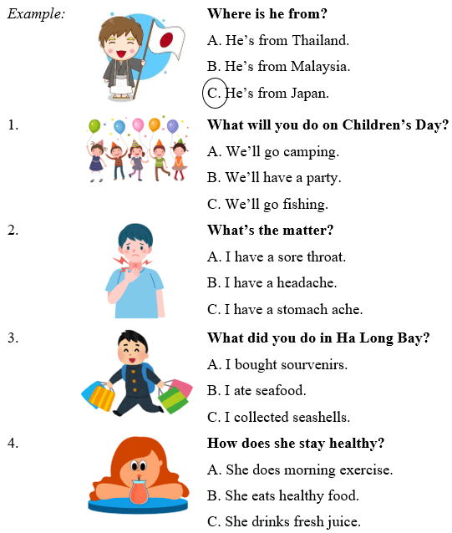

**IV. Read and circle.**

1. ______ they go to Ha Long Bay yesterday?

a. Do

b. Did

c. Does

2. We ______ in the sea with our parents last Sunday.

a. swam

b. swim

c. are swimming

3. ______ did you do in Singapore last summer?

a. When

b. Why

c. What

4. We ______ a lot of photos at Ba Na Hills last weekend.

a. took

b. take

c. are taking

**ANSWER KEY**

**I.**

***Audio script:***

Example: /w/ /w/

***Key:***

1. A     2. D      3. C     4. B

**II.**

***Audio script:***

1. A: Did you see Trang at the English club yesterday?

B: No, I didn’t. Oh… She went to Ha Long Bay with her family.

A: When did they go there?

B: They went there last weekend.

A: What did they do there?

B: They took a boat trip around the bay.

2. A: Have you ever visited Singapore, Quang?

B: Yes, I have. I went there with my family.

A: When did you go there?

B: We went there last summer.

A: What did you do there?

B: We took a lot of photos.

***Key:***

1. T    2. T    3. T    4. F

**III.**

1. B    2. A     3. A      4. C

**IV.**

1. b     2. a     3. c     4. a