1. speaking festival/ take part in/ school English/ Will you/ next Saturday? 🡪
2. going to/ isn’t/ stay/ in a hotel./ He 🡪
3. How long does it take you to ____ ready in the morning?
4. Is/ near/ a stadium/ there/ his factory? 🡪
5. My sister/ chocolate / come/ after lunch./ always has 🡪
6. in/ by letter./ We/ stay/ touch 🡪
7. COM_LETE
8. Children ___ be careful when they cross the road.

are do must have

1. I ___ a kite yesterday afternoon.
2. the town./ find a modern/ hotel in/ It is/ difficult to 🡪
3. What will the weather be like tomorrow? – It’ll be very cold and ___.

wind windy hot storm

1. has/ sceneries./ beautiful/ lots of/ My country 🡪
2. Katie’s hobbies ___ playing badminton and going shopping.
3. My teacher/ took/ last week./ a lot of photos/ on her holiday 🡪
4. Mr. Smith/ tomorrow./ be/ at the meeting/ won’t 🡪
5. twice/ brush/ a day./ your teeth/ You should 🡪
6. She needs/ vegetable/ bottle of/ oil and/ some rice. 🡪
7. Odd one out: classroom teacher doctor farmer
8. _ANUARY
9. Where’s Tom? – He’s ___ work.
10. Agatha Christie was an English detective _____. Her novel “ The Murder of Roger Ackroyd” was considered as one of the best novels ever.
11. Today is the last day of school. It is summer VACATION.
12. PART_
13. August is the hottest ___ this year.
14. How many hours ___ a day?

he works is he work does he work does he works

1. They sometimes ___ morning exercise at 5.30.
2. They / began/ forest./ in the/ to race 🡪
3. We are playing blind man’s ____ in the playground.
4. Linda is twenty years old. Jenny is eleven years old. Jenny is ____ than Linda.
5. Is the bank next ___ the post office.
6. in/ 1066?/ Who/ King of England/ became 🡪
7. Which sentence is correct?

There aren’t any oranges on the table. On the table aren’t there any oranges.

There aren’t oranges on any the table. There on the table aren’t any oranges.

1. What are you doing? - ___ are planting some trees. (We Us Our Ours)
2. We have/ such a happy/ fishing village./ delightful little / time in this 🡪
3. has an/ school/ The/ excellent/ library. 🡪
4. ___ colour are your daughter’s shoes? – They are brown.

Which Who What How

1. Tommy is ____ France. He’s French.
2. have breakfast/ to school./ going/ before/ You should 🡪
3. Lien spends too much money ___ clothes and shoes. (at to for on)
4. Please tell me ___ about your study. (many more few much)
5. ___ are you doing? – I’m watching sports on TV.
6. What is your sister doing? – She is playing the p____ upstairs. Can you hear the melody of the “Blue Danube”.
7. I can’t help you. I’m ___ good at English.
8. Her hat is beautiful. It means____.

It’s a beautiful hat. It’s a hat beautiful.

She has a beautiful hat. She has a hat beautiful.

1. Let’s go to the post _____. I need to send some letters.
2. Thanks for helping me carry that box. - ____ pleasure.

I am Mine My No

1. They would like some milk ___ dinner. (in at for of)
2. We learn about poems and novels in___.

History Literature Physics Chemistry

1. We ___ a beautiful lantern in Mid-Autumn Festival next Sunday.

will going to make are going to make make go to make

1. Lan and John are penpals. They ___ each other twice a month.

are writing write wrote writes

1. Little / is playing/ his toy car./ with/ John 🡪
2. He gave up ___ three years ago. He often smoked two packs of cigarette a day.
3. John has a bike but he never c_____ to work because it is far from his house.
4. There ___ much beer in the glass. (isn’t aren’t hasn’t doesn’t have)
5. Who are they staying ___? – Their parents.
6. their houses aren’t/ school every/ They walk to/ far from school./ day because 🡪
7. Mary’s mother made a new skirt___ her last week.
8. Does he/ need half/ two oranges?/ beef and/ a kilo of 🡪
9. AL_UD
10. Elisa is ___ something on her book. (writing writing wrote writes)
11. Japanese by yourself./ learn/ It is/ for you to/ difficult 🡪
12. Let ___ get some bread for you. ( I me mine my)
13. Would you like some toys ___ your children? (to in on for)
14. Who is the main ___in the story “The Adventures of Pinocchio”?
15. I have enough food in the house, so I needn’t ___ to the supermarket tomorrow.

to go will go go going

1. Classmate/ from Singapore./ We are/ going to have/ a new 🡪
2. Some people__ eat meat. (do never don’t never no never)
3. Joe’s father has a ___ of coffee in the morning.
4. You should ___ in bed until your fever goes away.
5. Susan/ speak?/ language/ does/ Which 🡪
6. FE_ALE
7. Put the computer on the TABLE.
8. We must stay here ___ 8.30 to 9.
9. These apples are mine and those are __. (she’s she is her hers)
10. the dentist/ visit/ You should/ at least/ 2 times a year. 🡪
11. yesterday/ I cleaned/ those shoes/ but they are/ dirty now. 🡪
12. I would like to be a nurse because I’d like to look after______.
13. from London/ did/ they travel/ How/ do Madrid ? 🡪
14. his party/ begin?/ does/ time/ What 🡪
15. We ___ going to go to Huong Pagoda this week.
16. We/ keep fit./ morning/ exercise regularly to/ do 🡪
17. Meet in/ the school/ gate./ We can/ front of 🡪
18. see/ a movie/ We are/ tonight./ going to 🡪
19. When it becomes hot, people often feel ___.

hungry thirsty happy worried

1. old./ Tim and Ken/ both/ 11 years/ are 🡪
2. We spend a lot of money ___ clothes. (to on with at)
3. BI_TH
4. at my school./ music/ different/ There are/ clubs 🡪
5. Goodbye! – Bye, ___ you later.
6. Yesterday/ Linda/ her birthday party./ invited me/ to 🡪
7. bedtime?/ often do/ your mother/ What does/ before 🡪
8. Phuong lives ___ her grandparents in Bat Trang Village. (on with of to)
9. Odd one out: festival week year month
10. They are ___ a new house near the lake.
11. ___ does your brother work? – He works in Ho Chi Minh City.
12. My dad HAS a pumpkin.
13. with his friends/ in winters./ skiing/ Tim/ sometimes goes 🡪
14. Stand __, please.
15. Peter ___ any jackets in his bedroom.

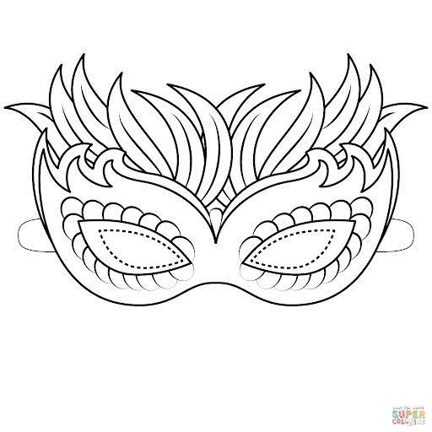hasn’t has got don’t have doesn’t have

1. I’m going to show some Indonesian ____ at the party.
2. I don’t like vegetables ___ my sister does.
3. His idea is quiet different ____ mine.
4. sailing/ never go/ in the/ We/ winter. 🡪
5. very interesting./ in he summer/ is/ swimming/ Going 🡪
6. often has/ before/ a big breakfast/ going to school./ Michael
7. SAN_WICH
8. Peter is watching some p_________ with his friends in his room.
9. a glass/ I’d like/ please./ of milk, / sandwich and 🡪
10. Are there ____ people in the garden? (some not any one)
11. Which word has the underlined part pronounced differently:

bean bread head ready

1. Mrs. Lien is at the store. She ____ some things.

buy buys to buy is buying

1. wear/ They/ in the winter./ warm clothes/ often 🡪
2. SINGAPOR_AN
3. tonight. / have/ We don’t / much homework/ to do 🡪
4. develop their/ Should all/ outdoors and/ children play/ social skills? 🡪
5. badminton/ in the morning./ sometimes/ He/ plays 🡪
6. Tom prefers eating ____ cooking.
7. There are ____ high buildings in Thailand. (many lot of a lots of much)
8. Would she like___?

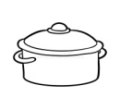The cup of iced coffee a cup of coffee iced a cup of iced coffee The cup of ice coffee

1. My mother uses the _____ to cook pumpkin soup.
2. John’s brother has a big flat on the fourth ______ of the building.
3. they/ have breakfast?/ usually/ What time/ do 🡪
4. What language ___? – English.

does he speak he speaks is he speak has he speak

1. In spring, it is warm ___ beautiful.
2. anything/ Is there/ in/ the clothes/ basket? 🡪
3. his homework/ for three hours/ Frank/ yesterday evening./ did 🡪
4. “Harry Potter” is on at 8 on HBO. Let’s ___ at my house and _____ together.

gather/ watching gathering/ watching gathers/ watches gather/ watch

1. When doing exercise, you s______ wear comfortable clothing.
2. My family often goes _____ a picnic at weekend.
3. Life in the countryside is pe_______.
4. time/ did/ What/ you get/ there? 🡪
5. What is ____ dessert, Mom? (to for of from)
6. Don’t _____ noise. The kid is sleeping.
7. What’s the weather _____? – It’s cloudy.
8. CAS_ETTE
9. their kites/ They sometimes/ in the/ fly/ park. 🡪
10. to the zoo/ often walk/ in 15 minutes./ from my house/ I 🡪
11. fables of children in/ the world./ is one of/ Aesop’s famous/ “The Tortoise and the Hare” 🡪
12. Who/ is/ phoning/ at the moment?/ you 🡪
13. Hoang goes to school ___ foot every day.
14. ROU_D
15. ___? - My parents.

What are you writing to Whose are you writing to

Which are you writing to Who are you writing to

1. can speak/ Mrs Green’s/ three/ family members/ languages. 🡪
2. at my/ house./ I’ll be/ Tomorrow/ grandparents 🡪
3. When ___ your family come back from the holiday? – Next week.

does is will was

1. Odd one out: sail stay throw desert
2. – Do you know the author of “Adventures of a Cricket”? – To Hoai, of course. It’s a piece of ___ ( candy pizza cake story)
3. I don’t like orange _____. I like lemonade.
4. Close/ books and/ your/ listen to/ my questions. 🡪
5. BET_EEN
6. She often _____ a bath in the evening.
7. My family is having m____ in the dining room.
8. your son/ usually have/ does/ What/ for breakfast?
9. Which word has the underlined part pronounced differently:

book pool stool school

1. Are you in my Art class? – Yes, I ___ ( ‘m am ‘re A&B)
2. Which word has the underlined part pronounced differently:

knife book chicken like

1. I will go to the supermarket to ___ some vegetables.
2. Which word has the underlined part pronounced differently

watches washes misses lives

1. 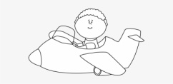Hai has to ___ an aspirin because he has a headache.
2. My mother is an English teacher and my father is a _____.
3. My grandpa is ____ but my grandma is light.
4. can find/ in almost/ every big city./ Today, you/ fast food restaurants 🡪
5. her/ Her mother/ many new clothes/ often buys/ at weekends. 🡪
6. ___ you like some coffee, Mary? – No, thanks.
7. What’s the matter ___ you? – I cut ____.

to/ myself at/ myself with/ myself with/himself

1. She is going to learn how to use a ____ in the class.
2. Are you ready ____ the exam? ( for on to with)
3. I brush my teeth a____ breakfast, lunch and dinner.
4. They are happy with their new HOUSE and they don’t want to leave.
5. _____ are you going to stay here? – For a week.

How often How long How many How far

1. Which word has the underlined part pronounced differently:

bus but picture up

1. What do you often do ____ your free time? (in at on with)
2. ____ will we go this summer? – We will go to Co To Island.

Where How What Which

1. free time/ any/ these days./ I don’t/ have 🡪
2. They/ in. /the evening./ at home/ aren’t
3. there and/ I’ll/ photo./ take your/ Stand
4. We sang and danced ___ at School Music Festival.

happy happily happyly happiest

1. 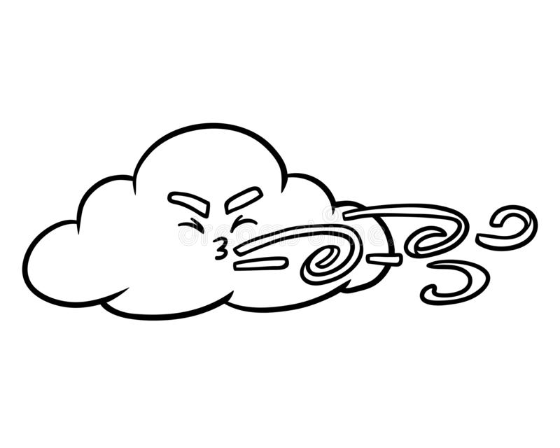is/ very interested/ in. My little brother/ cartoons. 🡪
2. – What’s the weather like today? – It’s _____.
3. When ___ your family buy a new house? – Next month. (did will do does)
4. How ___ money do you have?