[[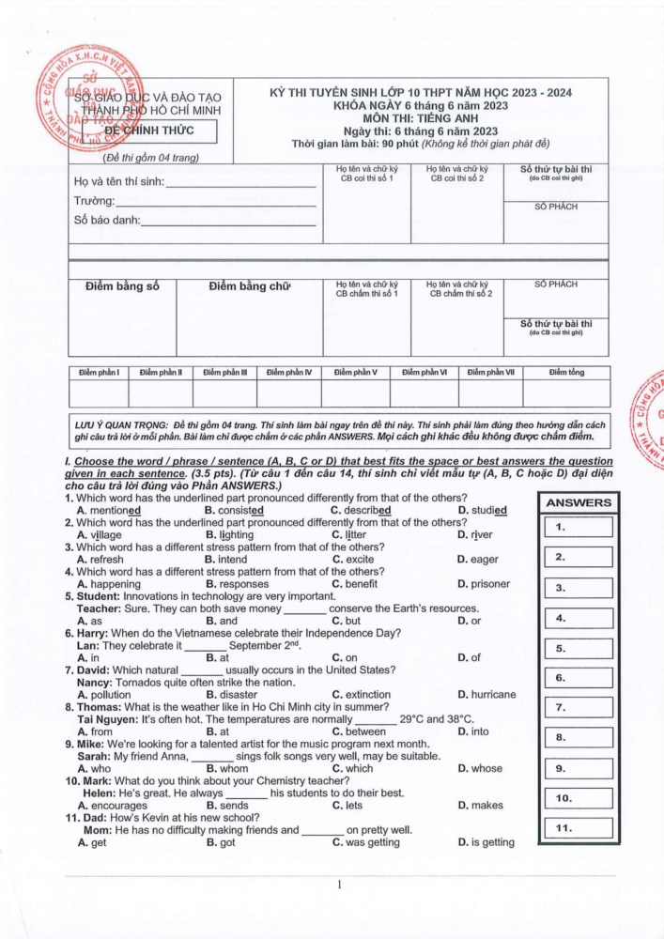](https://bnews.vn/dap-an-chinh-thuc-mon-tieng-anh-thi-vao-lop-10-nam-2023-tai-tphcm/294579.html#modal-media-image-290653)](https://bnews.vn/dap-an-chinh-thuc-mon-tieng-anh-thi-vao-lop-10-nam-2023-tai-tphcm/294579.html#modal-media-image-290653)[[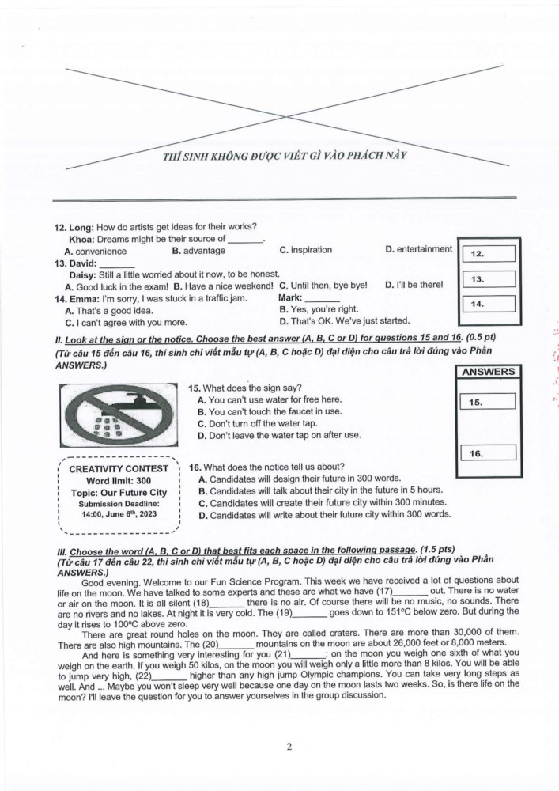](https://bnews.vn/dap-an-chinh-thuc-mon-tieng-anh-thi-vao-lop-10-nam-2023-tai-tphcm/294579.html#modal-media-image-290654)](https://bnews.vn/dap-an-chinh-thuc-mon-tieng-anh-thi-vao-lop-10-nam-2023-tai-tphcm/294579.html#modal-media-image-290654)[[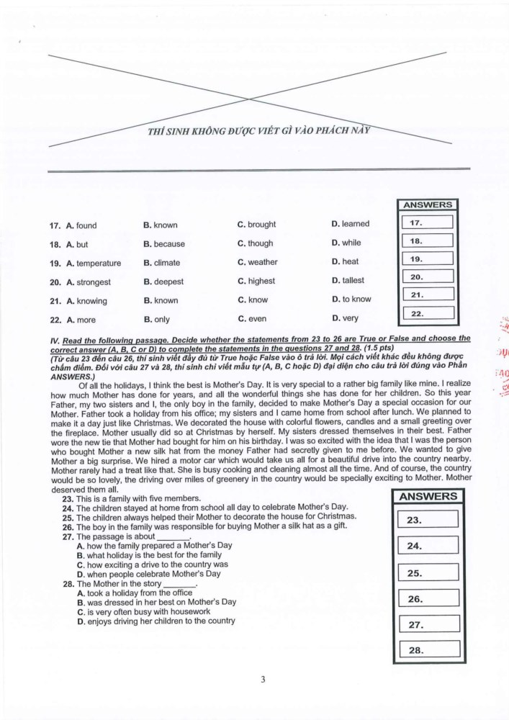](https://bnews.vn/dap-an-chinh-thuc-mon-tieng-anh-thi-vao-lop-10-nam-2023-tai-tphcm/294579.html#modal-media-image-290655)](https://bnews.vn/dap-an-chinh-thuc-mon-tieng-anh-thi-vao-lop-10-nam-2023-tai-tphcm/294579.html#modal-media-image-290655)[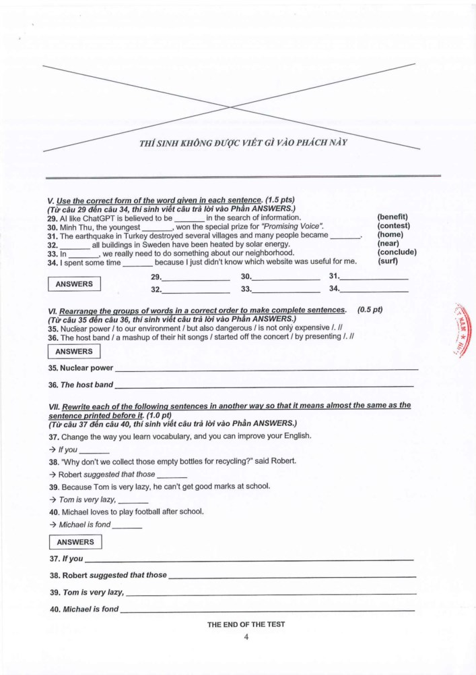](https://bnews.vn/dap-an-chinh-thuc-mon-tieng-anh-thi-vao-lop-10-nam-2023-tai-tphcm/294579.html#modal-media-image-290656)

**ĐÁP ÁN THAM KHẢO**

[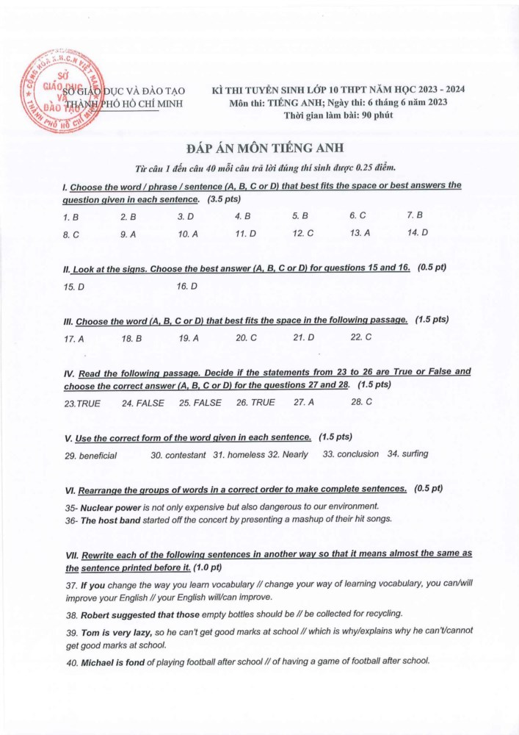](https://bnews.vn/dap-an-chinh-thuc-mon-tieng-anh-thi-vao-lop-10-nam-2023-tai-tphcm/294579.html#modal-media-image-290657)