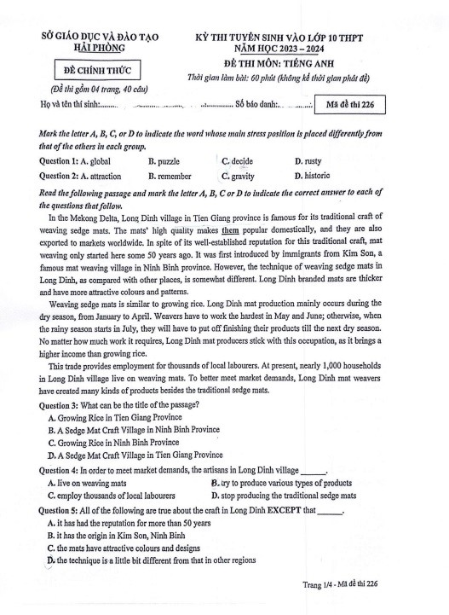

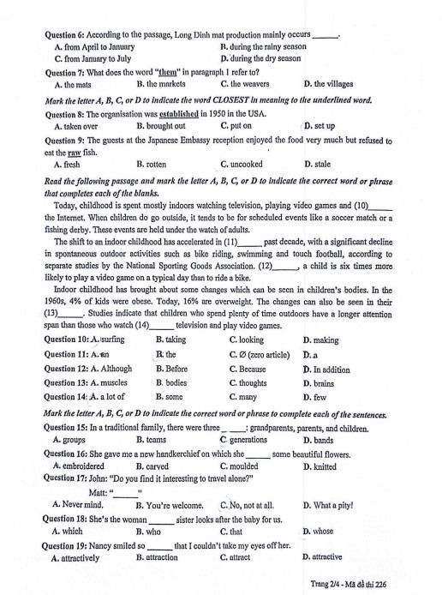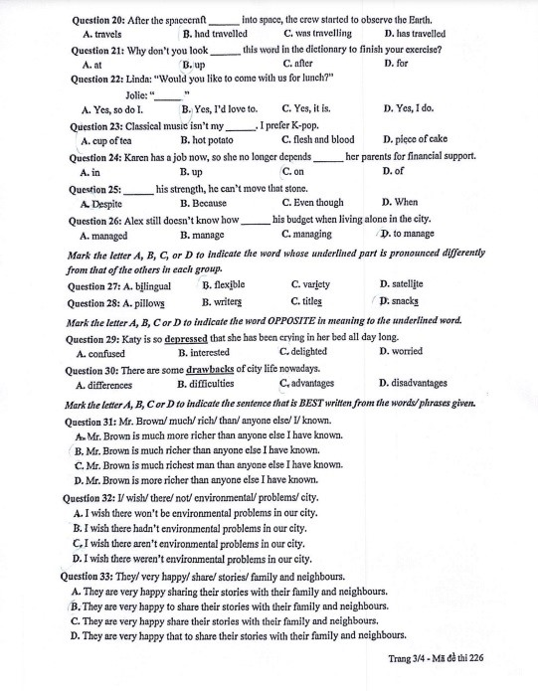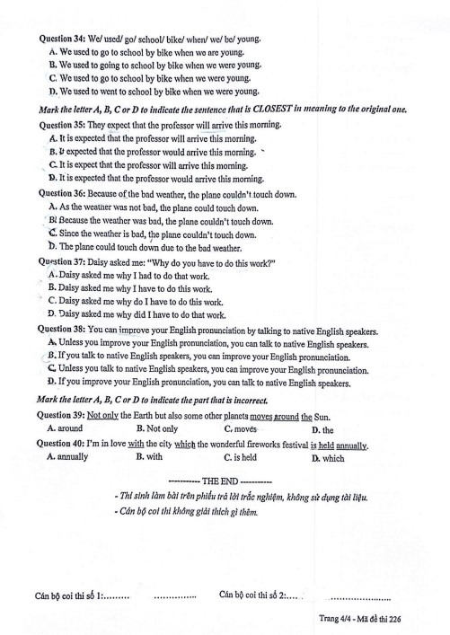

ĐÁP ÁN THAM KHẢO
1C 2C 3D 4B 5A 6D 7A 8D 9C 10A 11B 12D 13D 14A 15C 16D 17C 18D 19A 20B 21B 22B 23A 24C 25A 26D 27B 28D 29C 30C 31B 32D 33B 34C 35A 36B 37A 38B 39C 40D

